KYC Tool

A Know Your Customer decision support tool for medium-to-small chemical manufacturers / distributors

June 2023

Contents

Background 5

1. Introduction 7

Suspicious Indicators 7

2. Hardware and Software Requirements 9

3. Installation and Overview 10

4. SETUP 11

4.1. Customer Identification, Verification, and Database 11

4.1.1. Customer Verification Worksheet 11

4.1.2. Customer Database Worksheet 14

4.2. Product Risk Assessment and Product Database 14

4.2.1. Product Risk Assessment 14

4.2.2. Product Database 17

5. Customer Order 19

5.1. Order Information and Product Hazards 19

5.2. Order Verification 21

5.2.1. Customer History 21

5.2.2. Suspicious Activity 22

5.3. Transportation Verification 23

5.4. Completing a Customer order 26

6. Order Database 28

7. Interpretation of Results 30

7.1. Transaction Analysis Example 30

List of Figures

Figure 1. KYC Tool Customer Order Page with Tabs Shown In the Red Box 9

Figure 2. Customer Verification Page 10

Figure 3. Database tab which shows existing customer information 12

Figure 4. Product Risk Assessment tab of the KYC Tool 13

Figure 5. Chemical Inventory page 14

Figure 6. Customer Order tab in the KYC Tool 15

Figure 7. Sections of the Customer Order tab 16

Figure 8. Order Information and Product Hazards in Customer Order tab 16

Figure 9. Example form for filling out the Order Information and Product Hazards section of the Customer Order tab 17

Figure 10. Customer Verification section of the Customer Order tab 17

Figure 11. Mulcahy Institute example of Customer Verification section of Customer Order tab 18

Figure 12. Transportation Verification section of the Customer Order tab 20

Figure 13. Shipping request table within the Customer Order tab 22

Figure 14. Completed Customer Order tab for example purchase 23

Figure 15. Ordering Database tab showing fictional transactions 24

Figure 16. KYC Tool process flow diagram 25

# Background

The underlying concepts of Know Your Customer (KYC) are not new to the chemical industry. While the origin of KYC is not clearly discernable in history, the foundational concepts surrounding KYC started in the banking industry to determine the level of risk to the financial institution, such as the risk of a customer defaulting on a loan. Over time this concept evolved, due in part, to regulations for preventing financial crimes (e.g., tax evasion, organized crime activity, and even terrorism).[1] The concept we know now as KYC describes the process of assessing the accuracy of a customer’s identity and avoiding the misuse of banks or financial institutions by criminal organizations or terrorism. Depending on your country, this definition may be included in regulations related to banking security, Anti-Money Laundering (AML) or Anti-Terrorism Laws (ATL).[2] This basic concept is also generally considered as a business best practice to protect the company’s identity, reputation, and financial loss.

The concept of KYC for the chemistry industry began in the 1990’s following reports and incident investigations that occurred in Iraq and Japan. These reports all revealed the use of front companies/organizations[3] by governments and terrorist organizations to purchase dual-use chemicals for the production of chemical and biological weapons. Following the vulnerabilities identified in the reports to the chemical industry, chemical industry stakeholders began an initiative to implement KYC practices across the chemical supply chain. Currently, many chemical distributors or manufacturing associations support or require KYC measures by their members including those listed below (not an exhaustive list):

* Chemical Industry Association (CIA)
* Chemical Business Association (CBA)
* Cefic
* Responsible Care® - Product Stewardship
* SAICM - Global Product Strategy
* National Association of Chemical Distributors (NACD)
* Chemicals and Plastics Industry Training Program (PACIA)

The primary aim of KYC, for the chemical industry, is to help to prevent the proliferation of dual-use chemicals and chemical precursors for illegal activities. Dual-use, sometimes referred to as multi-use, is a term used to define chemicals (as well as equipment, knowledge, or software) that can be used for legitimate purposes or misused in the manufacturing of illicit drugs, explosives, or chemical weapons[ref]. Specifically, chemicals that directly or in combination with other materials pose a threat to public health and safety, agricultural crops, the environment, or national security. While this general term may include any chemical, there are a variety of organizations that have specifically defined the chemicals they consider to be dual-use or a high risk for misuse, such as the Organization for the Prohibition of Chemical Weapons (OPCW), Wassenaar Arrangement, and the Australia Group.[REF] Additionally, many countries have dangerous goods acts or anti-terrorism laws that define chemicals they consider dual-use and require specific licensing or handling measures, such as the U.S. CFATS, India SCOMET list, EU Seveso Directive.

This User guide provides guidance on the SNL-developed TESI tool which was designed to be used at a chemical facility that sells dual-use materials (e.g. chemicals and equipment) to evaluate the relative risk of the transaction. It is up to the policies and procedures of each organization to decide how to proceed with an order request.

# Introduction

The Transaction Evaluation for Suspicious Indicators (TESI) is a simple tool developed by SNL to help chemical distributors, suppliers, and retailers implement KYC best practices. The tool is designed around a framework that integrates an organization’s products, customers, sales, and shipping databases. This integrated database approach helps the facility to identify any abnormalities (or suspicious indicators) during the sale of their products that may be a security concern.

The goal of TESI is to identify high risk product sales, by showing the seller “Indicators” or flags prior to the product being sold or otherwise provided to a customer. . This tool has been developed to help chemical manufacturers or distributors directly selling products which contain dual-use chemicals in implementing KYC best practices. In the scope of this tool, dual-use chemicals are defined to include chemicals defined by OPCW, Wassenaar Arrangement or Australia Group, and those toxic industrial chemicals who pose a risk if used in a malicious scenario.

The KYC tool looks at a number of suspicious indicators including validation of the customer (ensuring they are who they claim to be), scrutinizing unusual orders (that may include orders outside the normal activity of a customer), changes in order placement or funding source, requesting unusual shipping routes or packaging, or asking unusual questions during the placement of the order which may raise suspicion about the intended use of the chemicals. The scope of the tool is for small to medium industries, but the underlying methodology can be applied across by any organization which sells products that may contain dual-use chemicals.

Suspicious Indicators

Typical operations vary from business to business and what is “normal” in some businesses may be unusual in another. The types of chemicals that are produced, stored, and distributed varies widely, transactions types will vary (e.g. cash-based vs credit-based), as will who customers are (companies, individuals, research institutes, international customers). Each individual business needs to determine its own normal operation to assess the risk of dual-use chemicals falling into the wrong hands. TESI provides a means for businesses to help manage their risk by further understanding what chemicals they have that might be used for malevolent ends and who they might be selling these chemicals to.

TESI analyzes the following aspects of a requested purchase for potential suspicious indicators:

* Customer identification and verification
  + Determining the customer’s identify and ensuring the customer does not raise suspicions
* Funding and bank verification & history
  + Scrutinizing funding mechanisms to ensure appropriateness
* Transportation verification & history
  + Scrutinizing transport methods/routes to ensure product arrives at the intended, *appropriate*, end user.
* Product Risk Management
  + Identify which products within a company’s inventory may pose a risk of misuse

In addition to the identification of suspicious indicators the TESI tool uses a colored ranking to reflect increasing numbers of suspicious indicators (green to yellow to orange). Each color category identifies increasing concerns regarding the end use or end user of the purchase, suggesting further communication with the customer. The flags indicate items which may raise concern and will indicate to the operator that the organization should be aware of risks to these transactions. A company using TESI will need to have or develop a well-defined process for actions to take following the detection of one, or multiple, suspicious indicators on an order. This could include delaying shipment until concerns are allayed up to the notification of relevant authorities, or anything in between. The actions should be aligned with the company’s risk tolerance as well as match any legal and industry specific standards.

TESI uses an order form which is intended to identify red flags by interfacing with multiple databases (Product Inventory, Customer Database, Past Order Activity) to identify risks in products being sold and customer history as well as red flags based upon customer behavior and how the product will be transported. This order form places all potential indicators in a single page so that a selling agent can easily identify them and evaluate the relative risk of the transaction. The following sections will detail how the tool supports the best practices as well as provide guidance on setting up and using the TESI tool.

# Hardware and Software Requirements

TESI was created and optimized for Microsoft Excel Version 2202 operating on Microsoft 365 Apps for enterprise. The Tool is configured to operate on any version of Excel after Excel 2007. The tool uses Visual Basic for Applications (VBA) Macros to perform analysis, any program will need to be able to read and run VBA Macros, which is a common feature of Microsoft Excel.

INSTALLATION and Overview

TESI is a Microsoft Excel spreadsheet. Installation is achieved by saving the file onto your computer.

# Installation and Overview

Upon the first installation, TESI will open on the “Customer Order” tab, where a customer order is placed and indicators will be identified. The tool consists of multiple tabs or worksheets which provide analysis and background for the indicators (Figure 1).

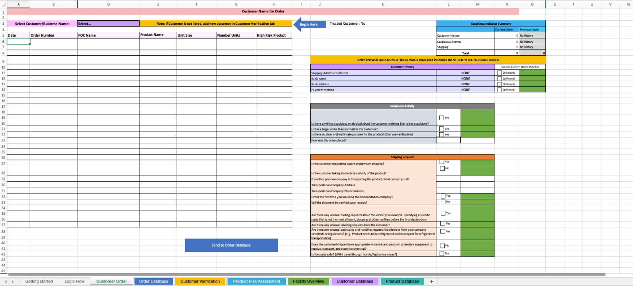

Figure 1. TESI Customer Order Worksheet with additional tabs shown In the Red Box

The seven functional tabs in TESI are:

* Customer Order- Primary page for sales associate to enter information related to a customer. This tab will identify suspicious indicators related to the transaction.
* Order Database- Provides past information on customer orders to allow a sales associate to analyze trends in ordering.
* Customer Verification- Page to gather primary information about a new customer and their financing. Verification of customers and financial institution can also be completed on this page.
* Product Risk Assessment- Page to allow new products to be analyzed to identify potential dual-use chemicals.
* Facility Overview- Page to gather basic information about the facility making the transaction.
* Customer Database- Provides a database of customers which have been previously verified.
* Product Database- Database of all products which have had product risk assessments conducted. Identifies red flag chemicals.

The following sections will provide detailed instructions on each of these tabs and the setup of the software.

1. SETUP

The programing in TESI is designed to work immediately, however it is highly encouraged that the user complete section 4.1-4.2 to identify current customers and evaluate the products that are available for sale.

* 1. Customer Identification, Verification, and Database

A customer identification program is the first component of KYC. In addition to collecting customer information, KYC best practices as include the verification of the customer information and tracking any abnormalities. TESI supports these KYC components with the “Customer Verification” and Database” worksheets.

4.1.1. Customer Verification Worksheet

Customer verification reduces the risk of products falling into the hands of someone with malicious intent. The objective is to ensure the customer is legitimate and will not use dual-use chemicals in an illegal manner.

One example where a front organization (false company) was used to purchase chemicals with malicious intent was in 1993, when the Japanese cult group Aum Shinrikyo used a number of them: Clarity Investments, Maha Posya, Bell Emoch, and Hasegawa Chemicals, to procure not only chemicals, but also a farm where chemical weapons were tested.[4],[5] If the companies selling the chemicals had done customer verification they may have identified red flags which could have prevented these sales, and the subsequent chemical weapon attacks.

The process for customer verification should align with the risks associated to the company and associated with the product. For most products being sold by small-to-medium sized companies, the verification process can focus on verification of addresses, payment processes, and name. More robust processes can include a detailed background screening of the customer and/or third-party verification. In addition to aligning with risks, the customer verification process may be limited or guided by specific legal requirements or standards.

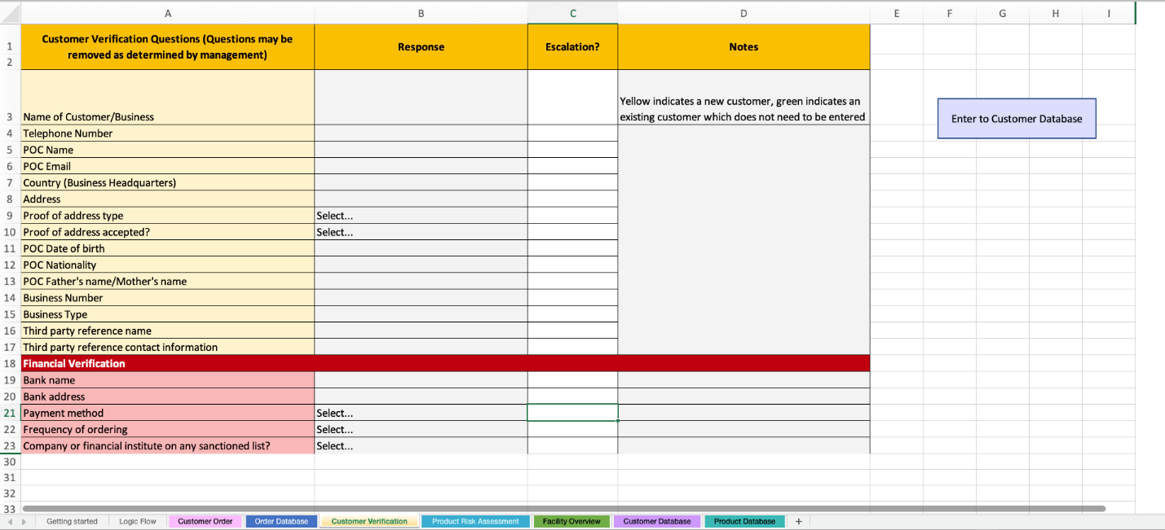

Figure 2. Customer Verification Worksheet

TESI is focused on a simplified process for customer verification, shown in Figure 2. This worksheet is designed to be used by the customer sales associate or other any employee that would collect new customer information. TESI includes a variety of questions to collect information on the customer. It is recommended that the facility review the questions and determine the applicability and accuracy for their business model and type of customer.

The Customer Verification worksheet includes these information categories:

* Name of Customer/Business- Customer name (may be a person or a purchasing company, facility, or institution)
* Telephone Number- Telephone number to reach the customer or the primary point of contact at the business
* POC Name- If a business is the customer, this field is option to identify the primary point of contact and/or authorized purchasers for the business.
* POC Email – Email address to reach customer
* Country – Country where the ordering company headquarters is located
* Address- Physical location of the customer or facility of the business. This is used in TESI for determining if a shipment is being sent to the same location. If the customer or business has multiple legitimate locations, the user will need to modify the database to track this information.
* Proof of address type- How the “Street Address” is verified (if necessary). A variety of options are given.
* Proof of address accepted?- Indicator field for address verification. Selecting “Yes” will confirm the location as accurate.
* POC Date of birth- This can be used to confirm identify of the point of contact in subsequent transactions
* POC Nationality- This field is the nationality of the POC placing the order.
* POC Father's name/Mother's name- This field is an optional field for higher security verification to confirm the identity of the “Point of Contact” for transactions determined by the user as high-risk.
* Business Number- Government issued unique identification number for company. Documentation and verification of the authenticity is highly recommended.
* Business Type- Type of business the customer operates, examples of a few selections are distributor, end-user, or retailer. This field is used to understand the customer and anticipate the typical business relationship and sales trends. This field can be used to highlight abnormal sale trends and can also used to verify the business type that matches the government issued license.
* Third-party reference name- Optional field to collect third-party references for the customer/business. This supports ensuring the customer has a legitimate need for the chemical based on a third-party confirmation. The reference could be another vendor, a customer of the customer, or a collaborator of the customer with whom legitimacy is well known.
* Third-party reference contact information- This field should include the primary contact information for the third-party reference.
* Financial Verification- For companies that do large transactions checking the validity of the financial institutions may be necessary to prevent misuse of chemicals.
* Bank name- Name of the financial institution or bank for payment.
* Bank address- Location of the bank listed in the “Bank Name” field.
* Payment method- How the customer is making their purchase. Cash or crypto currency payments are not guarantees of illegitimate purchases, but requests for this type of payment are considered higher risk. This may be dependent on the company’s normal business practices and cultural norms in the region. In areas or industries where cash payments are common, these do not raise the same suspicions.
* Frequency of ordering – Optional field used to understand customer purchasing trends.
* Company or financial institute on any sanctioned list?- It is highly recommended that the user review applicable sanctions list to verify that neither the customer, business name, or financial institution appear on them.

Once all applicable fields have been filled out, the button to the right labeled “Enter to Customer Database” can be pushed and the customer information will be saved in the Customer Database worksheet.

* + 1. Customer Database Worksheet

The Customer Database tab is database information that is used in the “Customer Order” worksheet when doing a sale. Existing customers can be viewed in the Database tab, shown below in Figure 3. For existing customers, their information can be verified and edited within this worksheet. If you already collect your customer information, you can input the information directly into the fields in this worksheet.

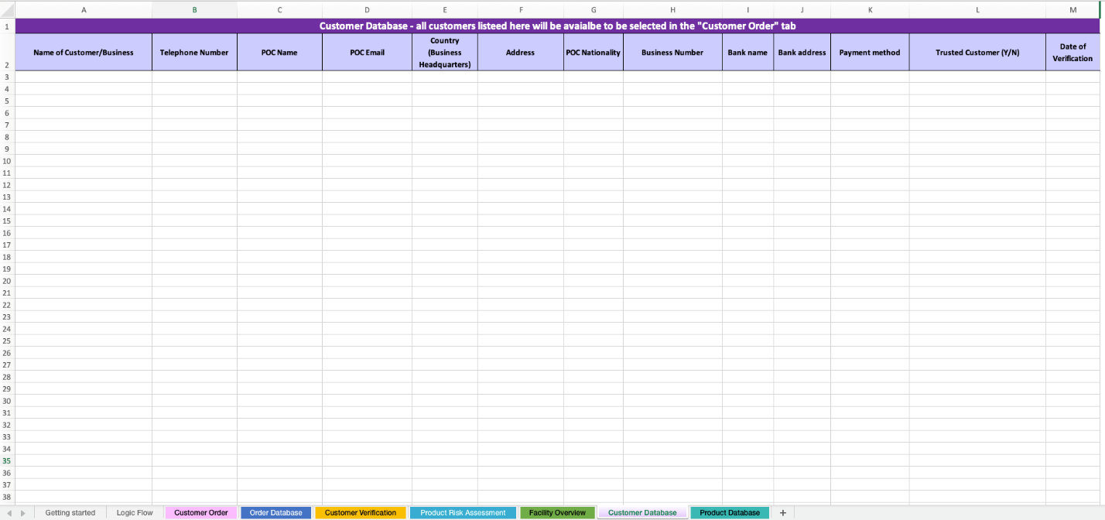

Figure 3. Database tab which shows existing customer information

* 1. Product Risk Assessment and Product Database

A key step in understanding the risks of the products you sell, first begins with knowing what products your have and the hazards or risks inherent to those products. TESI supports this by including a product risk assessment worksheet to help identify products with potential dual-uses and provides a product database as a tool to manage your product inventory.

4.2.1. Product Risk Assessment

For each product that is sold the company will need to complete the information in the “Product Risk Assessment” worksheet to determine the hazards and risks of the products. This page is designed to be completed by a person at the facility that is knowledgeable about the products such as the facility’s management or Safety and Security Officer. This page should be filled out prior to a customer sale and is used to populate the “Product Inventory” worksheet. Information about products can be found in a variety of places. For example chemical hazards can be found on a Safety Data Sheet (SDS) provided by the product manufacturer, or searched online at PubMed (https://pubmed.ncbi.nlm.nih.gov/), and the Europeans Chemical Agency (ECHA) website (<https://echa.europa.eu/>). Any known security concerns related to the product can be found on various international lists like those discussed earlier. The Product Risk Assessment worksheet (shown in figure 4) includes a variety of sections to be completed for the product risk assessment. This worksheet can be redesigned to meet the facility’s needs. The current worksheet includes nine sections initially designed for a chemical product risk assessment.

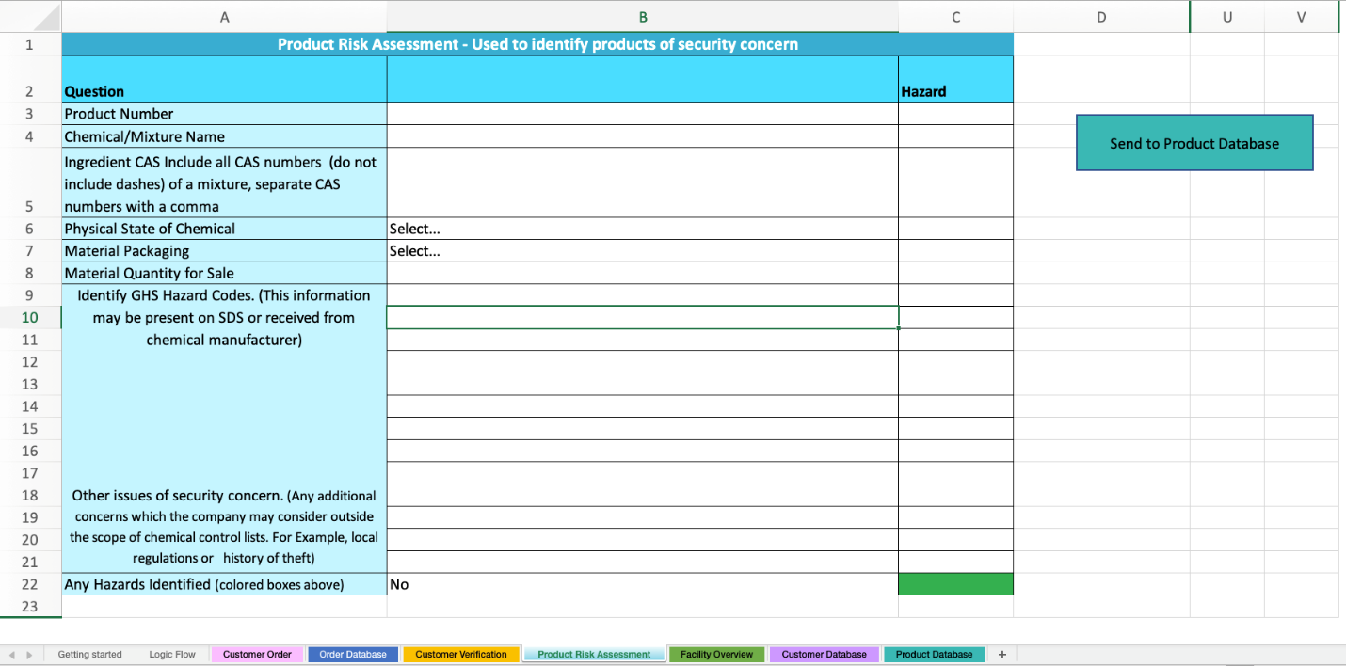

Figure 4. Product Risk Assessment tab of the KYC Tool

The Product Risk Assessment categories:

* The Product Number- How the product is identified by the company for inventory purposes, this may be letters, numbers, or combination of letters and numbers.
* Chemical/Mixture Name- The name of the product as it will be sold to customers (e.g., Chlorine, Window Cleaner)
* Ingredient CAS- The CAS number for ALL chemicals found in the product. A CAS number is a numeric identified that is unique for a chemical and may contain up to 10 digits. For example caffeine has a CAS number of 58-08-2. CAS numbers may be found by doing a search at <https://commonchemistry.cas.org> if you know the name of the chemical. CAS numbers can also be found in SDS sheets from the manufacturer of the chemical or mixture. CAS should be put into the KYC tool without dashes (for example caffeine would be put in as 58082 for CAS 58-08-2) and multiple CAS numbers can be placed with a comma separating each CAS. A red flag indicates that a chemical in the product is identified as a potential dual-use chemical due to inclusion on multiple lists of chemicals of concern by OPCW or the Australia Group.
* Physical state of chemical- Solid, liquid, or gas
* Material Packaging- The product packaging (e.g., amber glass bottle, plastic bottle, etc.)
* Material Quantity for Sale- The quantity the product is sold as. (e.g., 1L, 2 kg, etc.)
* GHS Codes- GHS Codes are part of the Globally Harmonized System of Classification and Labelling Chemicals (GHS) and provide a set of standardized phrases that relate to hazards associated with a chemical. Each CAS code is the letter H followed by a three-digit number. For example, H200 indicates Unstable Explosive and H300 indicates Fatal if Swallowed. This information can be found on the SDS or at [PubMed](https://pubmed.ncbi.nlm.nih.gov/) for a given chemical. Indicators in this section identify chemicals which can cause damage to people or the environment. Many chemicals have more than one GHS code and all the GHS codes for a chemical mixture should be entered. If a hazardous GHS code is entered a red indicator will appear. The table below shows the hazard codes that flag and what hazards they represent.

|  |  |
| --- | --- |
| Code | Hazard Statements |
| H204 | Fire or projection hazard |
| H206 | Fire, blast or projection hazard; increased risk of explosion if desensitizing agent is reduced |
| H207 | Fire or projection hazard; increased risk of explosion if desensitizing agent is reduced |
| H209 | Explosive |
| H210 | Very sensitive |
| H220 | Extremely flammable gas |
| H221 | Flammable gas |
| H224 | Extremely flammable liquid and vapor |
| H225 | Highly Flammable liquid and vapor |
| H228 | Flammable solid |
| H230 | May react explosively even in the absence of air |
| H232 | May ignite spontaneously if exposed to air |
| H240 | Heating may cause an explosion |
| H250 | Catches fire spontaneously if exposed to air |
| H260 | In contact with water releases flammable gases which may ignite spontaneously |
| H261 | In contact with water releases flammable gas |
| H282 | Extremely flammable chemical under pressure: may explode if heated |
| H300 | Fatal if swallowed |
| H301 | Toxic if swallowed |
| H310 | Fatal in contact with skin |
| H311 | Toxic in contact with skin |
| H314 | Causes severe skin burns and eye damage |
| H318 | Causes serious eye damage |
| H330 | Fatal if inhaled |
| H331 | Toxic if inhaled |
| H370 | Causes damage to organs |
| H400 | Very toxic to aquatic life |
| H401 | Toxic to aquatic life |
| H410 | Very toxic to aquatic life with long lasting effects |
| H411 | Toxic to aquatic life with long lasting effects |
| H271 | May cause fire or explosion; strong Oxidizer |

* Other potential areas of concern- Any additional concerns may be placed here which the company may consider outside the scope of chemical control lists or GHS codes. For example any additional security concerns you may have about a chemical. (e.g. if there is a history of theft for a given chemical in your region)
* Any Hazards identified- If there are any flags this should be Yes, otherwise it should be No.

Once all fields are completed hit the “Send to Product Inventory” button and the chemical will be placed in the “Product Inventory” database and the Product Risk Assessment worksheet will be cleared.

* + 1. Product Database

The “Product Database” worksheet is shown in Figure 5. This database provides the database for what appears in the “Customer Order” worksheet. The “Hazardous” column has “Yes” if the GHS codes entered in the “Product Risk Assessment” worksheet has a red indicator. This will appear as a red indicator on the Customer Order tab. Your facility can manually edit this field based on its decision of the Hazardous rating for a product. Additionally, if your company already has product information, then you can directly add the information to this database. The table can be sorted and viewed based on any of the column headers (Product ID, Product Name, CAS, Material Packaging, Material Quantity, and Hazardous).

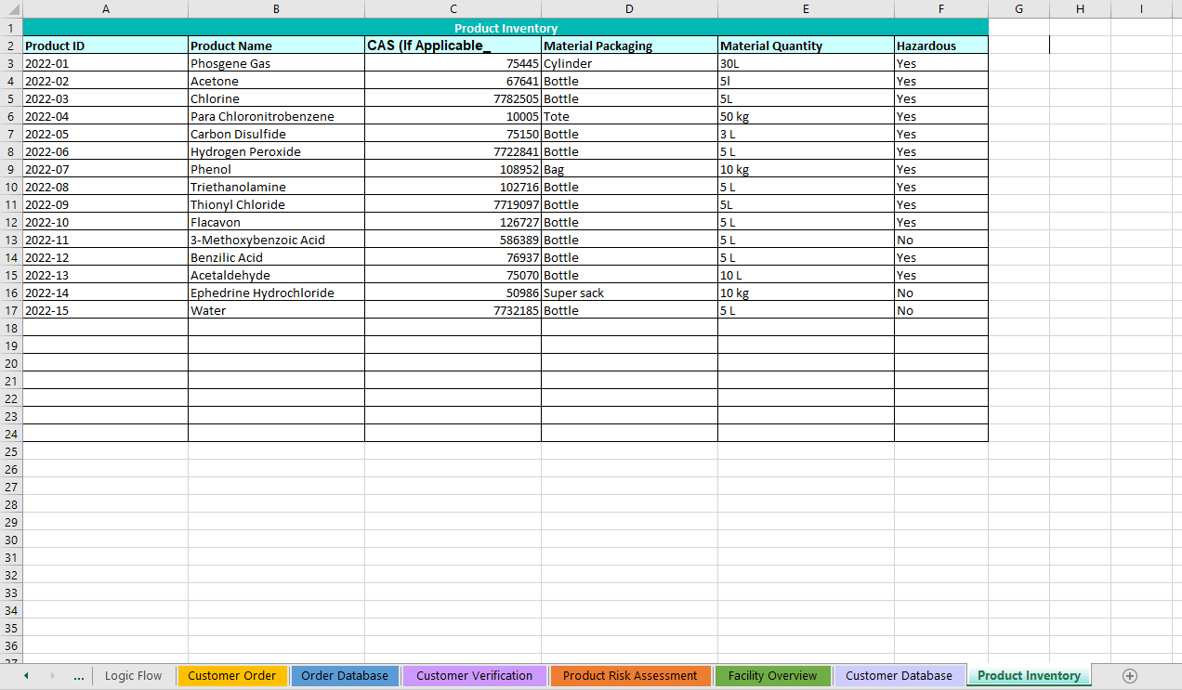

Figure 5. Product Database tab

1. Customer Order

The Customer Order worksheet is the main page for reviewing all the indicators when making product sales. This page it designed to be used by the sales associate processing the sale to identify any indicators or risks of the product sale. As mentioned before, TESI will provide the indicators, but it is up to the facility to determine the next steps to address the indicators and ultimately it is the facility’s decision to proceed with the sale. Figure 6 shows “Customer Order” worksheet.

Figure 6. Customer Order worksheet

There are three sections of “Customer Order worksheet, highlighted in Figure 7 as the Order Information and Product Hazards, Order Verification, and Transportation Verification.

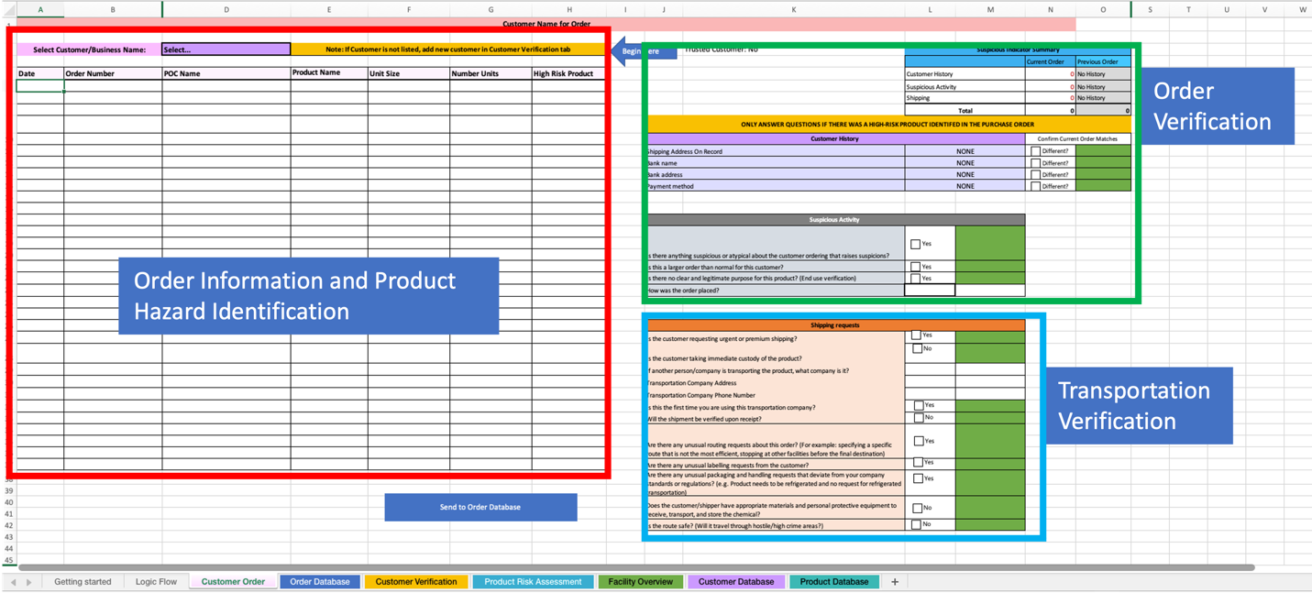

Figure 7. Sections of the Customer Order tab

* 1. Order Information and Product Hazards

The first section is the customer order details to be completed by the sales associate. This section is shown in Figure 8. The first cell to be complete is the “Customer Name for Order”. This is a drop-down list that relies on the information from the “Customer Database” worksheet. If the order is with a new customer, the customer would need to be put in the database in the “Customer Verification” worksheet. The user will then complete the next rows from left to right, using the drop-down list when necessary. Below is a list of information for each column on the customer order.

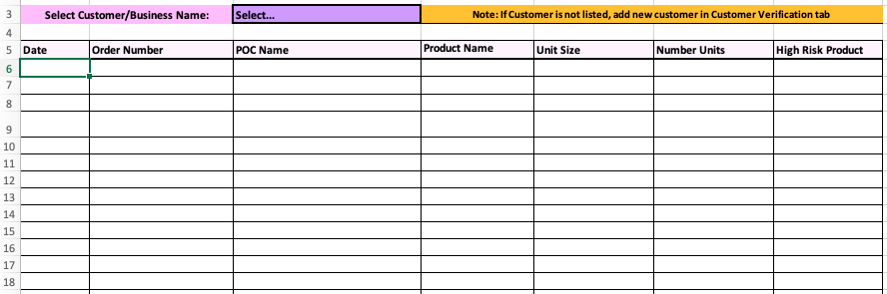

Figure 8. Order Information and Product Hazards in Customer Order tab

Customer Order Columns:

* Date- Date the transaction is being made
* Order Number- Optional field for the facility or company to use to track each specific order/transaction.
* Customer Name- This field is the “Name” of customer or person making the purchase. This may be the POC or authorized purchaser from a company.
* Product Name- This field is a drop-down list of the products your facility has added to the Product Inventory database.
* Unit Size- Field used to indicate the size or quantity for each product in the customer order
* Number Units- The number of each product in a particular size that are being purchased (e.g., two 1-liter bottles)
* High Risk Product- Indicator field that relies on the information from the “Product Risk Assessment” worksheet and is in the “Product Inventory” database. This indicator is either red or green (See Figure 9).

A completed order form in shown in Figure 9 as an example. The existing customer is Rekab Refinieries ordering 5 containers of Triethanolamine (4L) and 2 orders of Paraldehyde (25 L). The example transactions were completed on 25 and 26 May, 2023 and assigned an order number of 1 an 2 by the sales associate. One of the products generated a red indicator, which is based on the information in the Product Inventory worksheet. These red indicators are designed to highlight high-risk products that have a security concern for misuse.

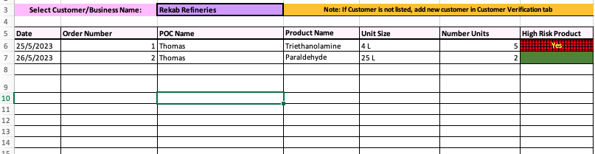

Figure 9. Example form for filling out the Order Information and Product Hazards section of the Customer Order worksheet

* 1. Order Verification

After the order details, the user will proceed to the “Order Verification” section of the Customer Order worksheet. This section, shown in Figure 10 is in two parts: the “Customer History” and the “Suspicious Activity” section.

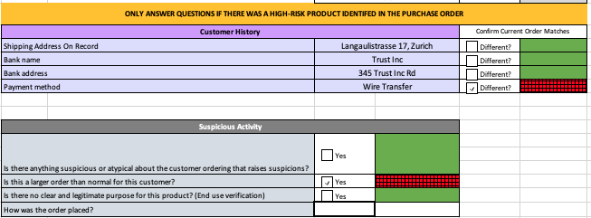

Figure 10. Customer Verification section of the Customer Order tab

5.2.1. Customer History

When a customer is selected in the “Customer Order” worksheet from the previous section, the “Customer History” table will be auto populated with information collected and stored in the Customer Database. The shipping address on record, bank name, bank address, and payment method should all be verified with the current order being placed. If these are the same then green color will show, however, if they are different then red color will show.

* + 1. Suspicious Activity

The “Suspicious Activity” section includes four questions that can be used by the sales associate to evaluate the general behavior and knowledge of the customer with the products in the sale. This section is a judgement or qualitative assessment about the suspiciousness of the specific customer present for the order. The question are:

* Is there anything suspicious or atypical about the customer ordering that raises suspicions?- This question is based on the opinion of the sales associate. Employee training can be given to improve this judgement based on specific unusual behavior to look for.
* Is this a larger order than normal for this customer?- The sales associate can check past records within the “Order Database” worksheet to verify previous order quantities.
* Does the customer have a clear and legitimate purpose for the chemical? This question helps determine if the customer has a real or legal reason to obtain the products. This section may be edited based on the facility needs. One example is to include a list of product uses for the sales associate to choose from and verify with the customer claimed use. Employee training can be given to improve this judgement based on specific unusual responses from the customer.
* How was the order placed? The method the customer made the order (in person, over phone, online).

A completed form in shown in Figure 11 as an example. The existing customer is Rekab Refineries and the sales associate determined that the shipping address on record, bank name, and bank address where all the same as past transactions, but the payment method had changed. Previously, Rekab Refineries had paid by Wire Transfer and for this transaction they requested to pay with a credit card. The sales associate talked to the customer on the phone and determined that they seemed nervous and suspicious. The order was consistent with previous products orders and they did have a clear purpose (they are a chemical distributor who regularly orders the same chemicals). Figure 11 below shows the indicators identified for this example. The changing of the payment method and the suspicious nature of the customer raise red indicators that should be reviewed and considered prior to completing the transaction.

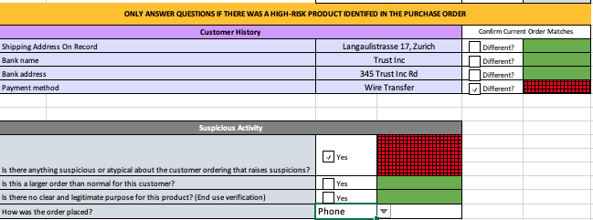

Figure 11. Rekab Refineries example of Customer Verification section of Customer Order tab

NOTE: In considering risks of malicious use of chemicals, instinct about the customer’s behavior should not be discounted. In some cases, this may be the only suspicious indicator for an order. The objective of customer personality review is to reflect on unusual or unexpected behaviors by the customer that could reflect problems upon receipt of the product. These may be behaviors signaling malicious intent, or someone unable to handle the safety requirements of the product.

Companies have prevented the sale of precursor chemicals to adversaries in the past simply by identifying that the buyer was acting suspicious. In the KYC tool, there is a single question reflecting on suspicion that also can be used for oddness in the order itself and not in the behavior: Is there anything suspicious or atypical about the customer ordering that raises suspicions? A ‘red’ flag for this should reflect a need to delay processing and management review of the order. This may also signal a need for external reporting of the order. These actions should align with the company policies and procedures which are defined outside the KYC tool.

* 1. Transportation Verification

The last section in the Customer Order worksheet is the Transportation Verification section. This section, shown in Figure 12, is used to determine how the customer will take ownership of the product, such as shipping or personal pick-up. This may not be appropriate for all companies and can be edited to meet the facility or company needs.

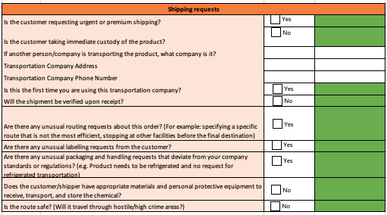

Figure 12. Transportation Verification section of the Customer Order tab

The questions in this section are:

* Is the customer requesting urgent or premium shipping?
* Is the customer taking immediate custody of the chemical? To determine if the customer is using a third-party transportation or logistics company before obtaining the chemical. If the customer usually ‘picks’ up the product this may not be a suspicious indicator, however, if this is unusual this would be considered suspicious and colored in red.
* If another person/company is transporting the chemical, what company is it? If the answer to the previous question is “Yes”, then this determines who the transportation company is. This helps to ensure the transportation company is a legitimate company and not a front company for a chemical trafficker or someone with malicious intent.
* Transportation Company Address- Contact information for the transportation company. This helps to ensure the transportation company is a legitimate company.
* Transportation Company Phone Number- Contain information for the transportation company. This helps to ensure the transportation company is a legitimate company. Phone contact information can also be important safety information to have as well.
* Have you ever worked with this Transportation Company before? Determines if this is a new transporter or a known and trusted transportation company.
* Will the shipment be verified upon receipt? If the customer is using a transportation company, will they verify that the product arrives where it is supposed to go?
* Are there any unusual routing requests about this order? (For example: specifying a specific route that is not the most efficient, stopping at other facilities before the final destination) These may reflect attempts to by-pass legal requirements for transport or allow for diversion during transit or to put the products in an area where there is high theft.
* Are there any unusual labelling requests from the customer? These may reflect attempts to by-pass legal requirements for transport or allow for diversion during transit, especially if border crossings are involved in the transport.
* Are there any unusual packaging requests that deviate from your company standards or regulations? These may reflect attempts to by-pass legal requirements for transport or allow for diversion during transit
* Does the customer/shipper have appropriate materials and personal protective equipment to receive, transport, and store the chemical? This helps determine if the customer has a legitimate purpose for the product. If they can not safely handle the product they may not be intending to use it for the intended purpose.
* Is the route safe? (Will it travel through hostile/high crime areas?) This determines if the product is more likely to be stolen during transit.

Each company will need to determine actions to take for any red and yellow indicators highlighted in the transportation section. It is recommended that ‘red” indicators in the transportation section require additional review and reporting to management before an order is processed. This may also signal a need for external reporting. These actions should align with the company’s policies and procedures defined outside TESI. Yellow indicators reflect uncertainty in the transaction and based on defined procedures, may delay in processing until questions can be answered by the customer.

A completed example in shown in Figure 13 for the existing customer Mulcahy Institute. The customer is using a third-party transportation company, Yalla Shipping, to transport the shipment. There will be no verification upon receipt by the customer, but the transportation company has been used before and there are no unusual requests about the route or packaging. Figure 13 shows the color indicators that would be generated by this example within the TESI tool. For this example order, two red indicators were identified (no immediate custody by customer and no verification upon receipt).

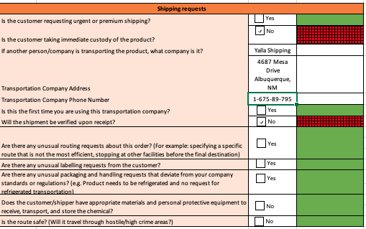

Figure 13. Shipping request table within the Customer Order tab

* 1. Completing a Customer order

Once the three sections of the Customer Order workshop are completed, the facility or company can analyze the indicators present for the specific order and determine whether to proceed with the sale. A completed worksheet is shown in Figure 14 for the Rekab Refineries example. There are multiple red indicators within this order. A sales associate can analyze these indicators to determine whether to proceed. The indicators are as follows:

* Order Information and Product Hazards- One red flag indicating one of the products is a dual-use chemicals and could pose a risk. This alone should not stop a transaction, but it does mean that the customer and transportation should be verified.
* Customer Verification- Two red flags indicating the purchase method has changed from past actions and the customer acted suspicious. This combined with the hazardous chemicals may begin to make a company question whether to proceed with the sale.
* Transportation Verification- Two red flags show the customer is not taking immediate custody of the product and they will not be verifying the receipt of the product upon arrival.

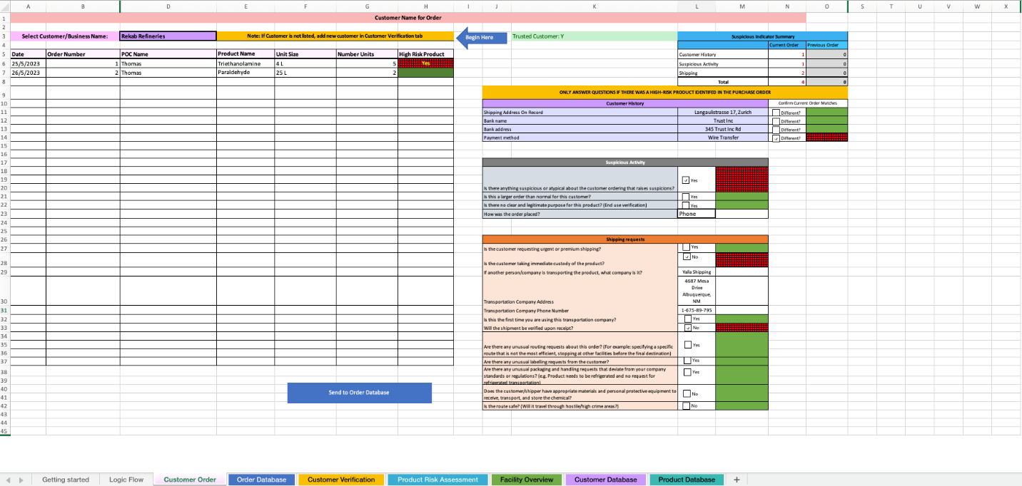

Figure 14. Completed Customer Order tab for example purchase

A red indicator does not directly mean the order is suspicious, but rather the something in the order is a concern based on the product or abnormalities based on the customer. Some red indicators can be addressed by contacting the customer company POC (when applicable) to verify any changes to address, payment, shipping, and ordering trends. Ultimately, it is up to the facility to decide on the level of escalation required for each order and whether to proceed with the transaction.

After the transaction is completed click the “Send to Order Database” to transfer the order to the “Ordering Database” worksheet and clear the screen for the next transaction.

6. Order Database

The TESI tool collects past orders from customers to allow the users to quickly review past order trends. Figure 15 shows the Ordering Database worksheet from the TESI Tool. This database stores information from the Customer Order worksheet so that past actions from customers can be analyzed for trends.

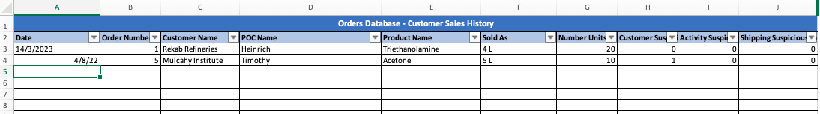

Figure 15. Ordering Database tab showing fictional transactions

This database stores the following information:

* Date- Date the transaction was made
* Order Number- Company defined order number for each transaction
* Customer Name- Customer (business) who made the transaction
* POC Name: Individual representative from the customer who made the transaction
* Product Name- Product which was sold in the transaction
* Sold As- Quantity of product sold from previous column
* Number Units- How many of each quantity of material was sold in the transaction
* Customer Suspicious Indicators – Tally of the number of red flags found in a prior order in section of order worksheet
* Activity Suspicious Indicators -– Tally of the number of red flags found in a prior order in section of order worksheet
* Shipping Suspicious Indicators – Tally of the number of red flags found in a prior order in section of order worksheet

Each column can be filtered within the Excel spreadsheet to show any specific customer order when reviewing past transaction to check if purchasing activities have changed over time (e.g., hazardous chemicals being purchased in larger quantities than previously ordered).

# Interpretation of Results

The process flow for the TESI tool can be seen in Figure 16 below. The goal is to be able to make an informed decision about whether to proceed with a sale based on information on the product being sold, the customer purchasing it, and how it is to be transported. The “Product Risk Assessment” and “Product Inventory” worksheets provide information on hazards related to the product, the “Customer Verification” and “Database” worksheets provide information on the customer purchasing it, and questions within “Customer Order” provide information on how it will be transported. All are important to understand the risks of a sale.

Once all the information has been gathered and put into the tool, a quick analysis can be made about the number of red or yellow indicators. Decisions can be made whether to complete a transaction or to follow-up with questions and additional information before determining whether to complete a transaction.

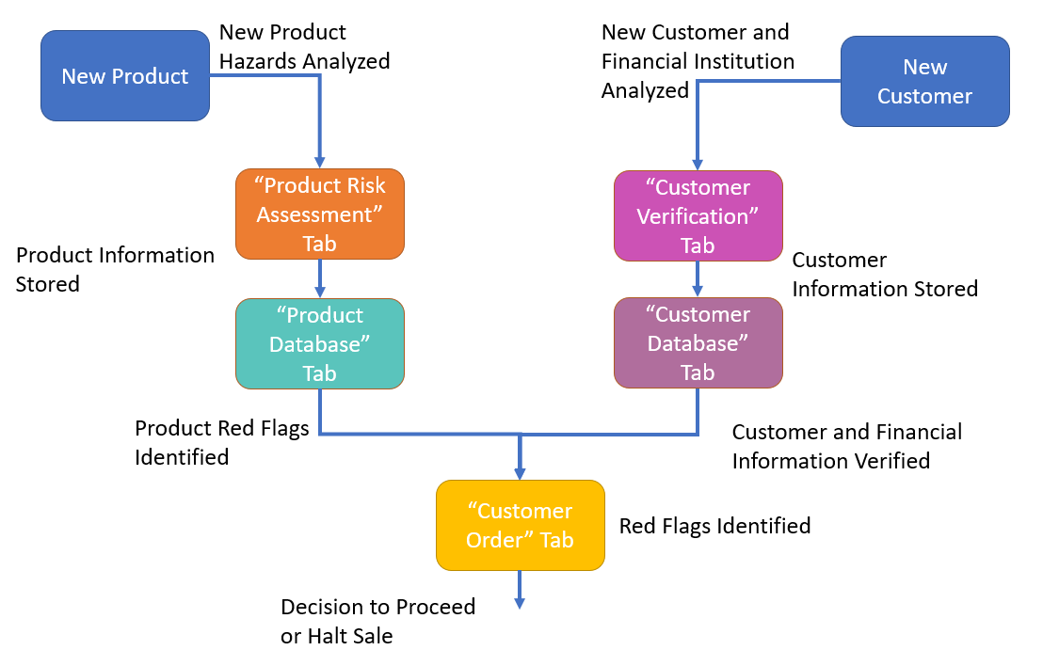

Figure 16. KYC Tool process flow diagram

* 1. Transaction Analysis Example

Provided in this section is an example method of combining each indicator to determine the risk of the transaction. Below is a 3-step accumulation of indicators to highlight the level of risk from low to high. The color indicators are “green” for low risk, “yellow” for medium risk, and “orange” for higher risk.

Step 1: Begin with the “Customer Verification”, which includes first determining if the customer is new or existing.

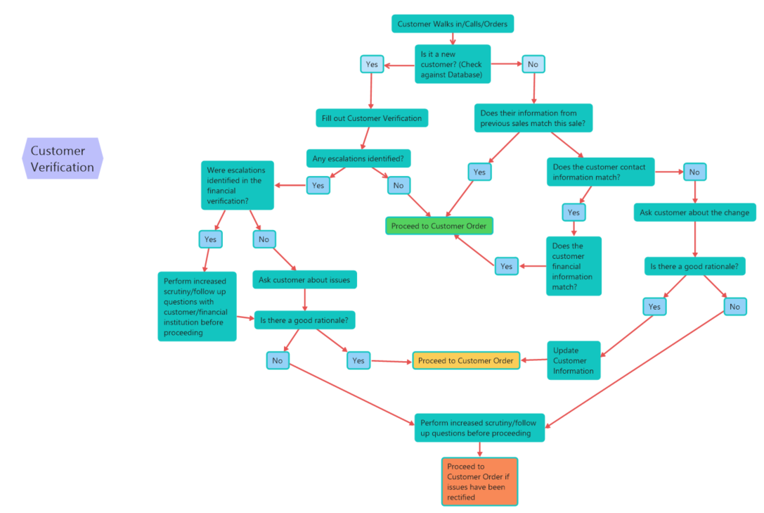

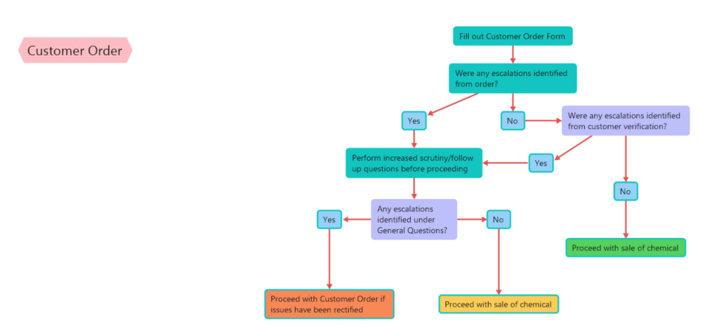Step 2: Evaluate the Customer Order. The blue color boxes pull in the information highlighted in Step 1 which may raise or lower the accumulated risk for the transaction.

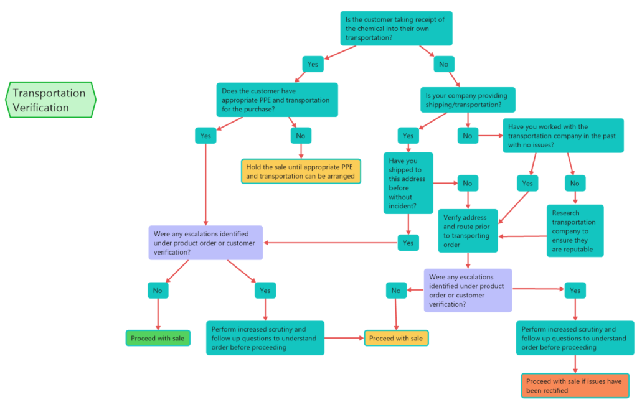Step 3: Evaluate the shipping method for the transaction. As with Step 2, the blue color boxes pull in the information highlighted in Step 1 which may raise or lower the accumulated risk for the transaction.

1. <https://businessforensics.nl/kyc-financial-crime/>
2. https://www.occ.treas.gov/topics/supervision-and-examination/bsa/index-bsa.html
3. A “front company” is a term for an individual, group, or organization which is used to prevent identification of an owner or individual of another organization. These may be used to hid another organization or individual from liability or legal scrutiny.
4. https://irp.fas.org/congress/1995_rpt/aum/part06.htm
5. https://digitalcommons.usf.edu/cgi/viewcontent.cgi?article=1510&context=jss