**TESI© Software**

User Manual

TESI

Transaction Evaluation for Suspicious Indicators



© Sandia National Laboratories

P.O. Box 5800

Albuquerque, NM 87185

Sandia National Laboratories is a multimission laboratory managed and operated by National Technology and Engineering Solutions of Sandia LLC, a wholly owned subsidiary of Honeywell International Inc. for the U.S. Department of Energy’s National Nuclear Security Administration under contract DE-NA0003525.

SANDXXXXXX



Table of Contents

1 Introduction 5

1.1 Implementation and Maintenance 5

1.2 Suspicious Indicators 6

2 Software Installation 7

2.1 Hardware and Software Requirements 7

2.2 Download 7

2.3 Run the Application 7

3 Overview of Software Navigation 7

3.1 Basic Navigation 7

3.1.1 Home Page 7

3.1.2 Navigation Bar 9

3.1.3 Text Size and Zoom 9

4 Application Setup 10

4.1 Software Setup (Facility Overview) 10

4.2 Configure Table Displays 12

5 Orders Icon 14

5.1 Overview and Basics 14

5.1.1 New Order 14

5.1.2 Active Orders 21

5.1.3 All Orders 22

5.1.4 Edit an Order 22

5.1.5 Delete an Order 22

6 Customers Icon 22

6.1 Overview and Basics 22

6.1.1 Customer List 23

6.1.2 Filter Customer List 23

6.1.3 Add Customer to Database 23

6.1.4 Sanctioned Entity Matches 26

6.1.5 Edit Customer Form 27

6.1.6 Delete Customer from Database 27

7 Product Icon 28

7.1 Overview and Basics 28

7.1.1 Products Page View 28

7.1.2 Filter Product Database 28

7.1.3 Adding a New Product 29

7.1.4 Edit a Product 31

7.1.5 Delete a Product 31

8 Interpretation of Results 31

8.1 Transaction Analysis Example 32

Appendix A. Technical Information and References 36

A.1. Exporting Data from TESI 36

A.2. Importing Data into TESI 37

A.3. Definitions 40

A.4. Acronyms 41

A.5. Sanctions Lists 42

A.6. Troubleshooting 42

9 Index 43

**FIGURES**

Figure 1. TESI home page 8

Figure 2. Overview of the TESI navigation icons 9

Figure 3. Overview of the TESI navigation bar 9

Figure 4. Facility overview page (example) 11

Figure 5. Select columns to be displayed in a table 13

Figure 6. Overview of TESI “New Order” tab on the “Orders” page 15

Figure 7. Product hazards flag shown 16

Figure 8. Completed Customer Order tab (example) 20

Figure 9. Screenshot of "Active Orders" tab on Orders page 21

Figure 10. Overview of TESI “All Orders” tab on Orders page 22

Figure 11. Overview of the TESI Customers page 23

Figure 12. Filtering the TESI Customer Database view 23

Figure 13. Overview of the TESI Customer Verification form for adding new customers 26

Figure 14. Sanctioned Entities dialog box 27

Figure 15. Delete Customer dialog box 27

Figure 16. Overview of the TESI Products page 28

Figure 17. Action buttons on Products page 29

Figure 18. Example of a filled-out Product form 31

Figure 19. KYC Tool process flow diagram 32

Figure 20. KYC Tool Customer Verification process flow diagram 33

Figure 21. KYC Tool Customer Order process flow diagram 34

Figure 22. KYC Tool Transportation Verification process flow diagram 35

Figure 23. Manage Data Import/Export menu 36

Figure 24. Export data options 37

Figure 25. Import data options screen 39

Figure 26. Import data error message example 39

**TABLES**

Table 1. GHS H-codes 30

# 

# Introduction

Transaction Evaluation for Suspicious Indicators (TESI©) is a simple tool developed by Sandia National Laboratories (SNL) to help chemical distributors, suppliers, and retailers implement Know Your Customer (KYC) best practices for dual-use chemicals. In the scope of this tool, dual-use chemicals include chemicals defined by the Organisation for the Prohibition of Chemical Weapons (OPCW), Wassenaar Arrangement, or Australia Group, as well as toxic industrial chemicals that pose a risk if used in a malicious scenario.

The tool is designed around a framework that integrates an organization’s products, customers, sales, and shipping databases. This integrated database approach helps the facility to identify any abnormalities (or suspicious indicators) during the sale of their products which may be a security concern. The goal of TESI is to identify high-risk product sales by showing the seller suspicious indicators or “red flags” prior to the product being sold or otherwise provided to a customer.

The KYC tool looks at a number of suspicious indicators, including validation of the customer (ensuring they are who they claim to be), scrutinizing unusual orders (may include orders outside the normal activity of a customer), changes in order placement or funding source, requesting unusual shipping routes or packaging, or asking unusual questions during the placement of the order which may raise suspicion about the intended use of the chemicals. The scope of the tool is for small-to-medium companies, but the underlying methodology can be applied across any organization selling products that may contain dual-use chemicals.

**NOTE**: The TESI software is only one example of sales management or Customer Relationship Management (CRM) software that can be used. There are others in forms in varying complexity. We encourage further investigation into available software to best fit your management system needs.

A proper sales management system will ultimately lead to better data integration, automation, and data reporting capabilities for both the identification of suspicious indicators as well as sales management. These benefits not only reduce time and resource costs but also improve recordkeeping, which supports historical data analysis. The TESI software is easy to use and implements a chemical sales database system that supports broader sales operations.

## Implementation and Maintenance

A CRM is a “living system,” which means that it requires continual updates and maintenance. To maintain a proper CRM, requirements include: (1) documentation and record keeping, (2) assigning roles and responsibilities, (3) training new staff, and (4) reporting. Standard operating procedures (SOPs) are highly recommended to properly document staff responsibilities, operations, and training requirements.

Your CRM SOPs should address:

* Roles and responsibilities for all lab users and administrators, including laboratory managers, stockroom managers, laboratory staff, and technicians
* Requirements for access privileges, access controls, password protection, and protected sharing of inventory information
* Backing up data and information with security protections
* Procedures/requirements for purchasing, delivering (or distributing), adding to and removing/modifying inventory items
* Training requirements and training schedules for all the TESI software users
* Reporting requirements and reporting schedule
* Inventory audit schedule and procedures

## Suspicious Indicators

Typical operations vary from business to business; what is “normal” in some businesses may be unusual in another. The types of chemicals that are produced, stored, and distributed vary widely. Transaction types will vary (e.g., cash-based vs credit-based), as will the customer types (companies, individuals, research institutes, international customers). Each individual business needs to determine its own normal operation to assess the risk of dual-use chemicals falling into the wrong hands. TESI provides a means for businesses to help manage their risk by further understanding which chemicals they have that could be used for malevolent ends, as well as who they might be selling these chemicals to.

TESI analyzes the following aspects of a requested purchase for potential suspicious indicators:

1. **Customer identification and verification**
   * Determines the customer’s identity and ensures the customer does not raise suspicions
2. **Funding, bank verification and history**
   * Scrutinizes funding mechanisms to ensure appropriateness
3. **Transportation verification and history**
   * Scrutinizes transport methods/routes to ensure product arrives at the intended, *appropriate* end user
4. **Product Risk Management** 
   * Identifies which products within a company’s inventory may pose a risk of misuse

In addition to the identification of suspicious indicators, the TESI tool maintains a count of flags in each category for comparison with the previous order from that customer. These counts provide a way to quickly gauge increasing concerns regarding the end use (or user) of the purchase, suggesting further communication with the customer. The flags indicate items which may raise concerns and will indicate to the user that the organization should be aware of the risks in these transactions. A company using TESI will need to have or develop a well-defined process for actions to take following the detection of one (or multiple) suspicious indicators on an order. This could include delaying shipment until concerns are allayed, notification of relevant authorities, or anything in between. The actions should be aligned with the company’s risk tolerance and match any legal and/or industry-specific standards.

TESI uses an order form, which is intended to identify red flags by interfacing with multiple databases (Products, Customers, and Orders) to identify risks in the products being sold and relevant customer history, as well as suspicious activity based upon customer behavior and how the product will be transported. The order form has all potential indicators on a single page so that a selling agent can easily identify them and evaluate the relative risk of the transaction. The following sections detail how the tool supports best practices, as well as provide guidance on setting up and using the TESI tool.

# Software Installation

## Hardware and Software Requirements

Hardware requirements to operate the TESI software include a modern computer with a browser that supports modern web technologies. For optimum graphic display, Mozilla Firefox, Google Chrome, and Microsoft Edge are the recommended browsers for use with TESI. Microsoft’s Internet Explorer is not capable of displaying TESI pages correctly.

## Download

The first step is to download a copy of the application and save it either to your local computer or a shared network drive. The TESI software is available in three versions, depending on your computer’s operating system:

* Windows (tested on Windows 11)
* macOS (tested on Sonoma)
* Linux

Download the application file matching the operating system of the computer you will be using. The application contains a working database internally, so each copy of the file is a separate, independent instance of the database. TESI is packaged as a single application file, so no installation process is needed.

## Run the Application

Once you have saved the application, double-click the file to run the application. The TESI application will open in your default browser (which should be one of the browsers listed in Section 2.1 above).

# Overview of Software Navigation

*The steps provided in this section demonstrate basic navigation through the TESI software.*

## Basic Navigation

### Home Page

The Home Page appears when the user opens the application. This screen is a tile view of icons.

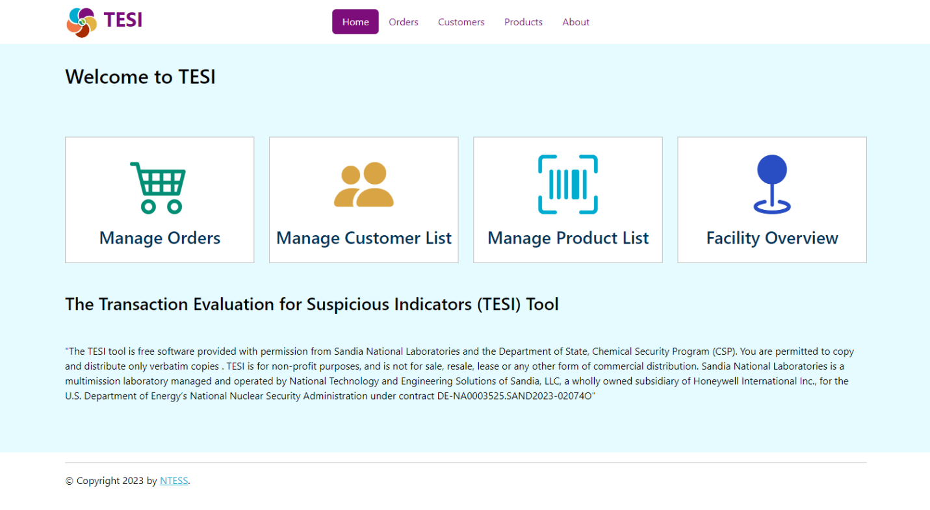

Figure 1. TESI home page

Below is a brief description of each icon on the Home Page. This manual features a detailed section for each icon.

|  |  |
| --- | --- |
|  | ***Manage Orders* Icon** is used to evaluate and record new orders, as well as view active orders and previous order history. |
|  | ***Manage Customer List* Icon** is used to enter and manage customer information. |
|  | ***Manage Product List* Icon** is used to add and manage information about the products your company sells. |
|  | ***Facility Overview* Icon** is used to record baseline information about how your company or facility operates and how sales are typically conducted in your market environment. |

Figure 2. Overview of the TESI navigation icons

### Navigation Bar

The navigation bar appears at the top of the Home Page when any icon on the home screen is clicked. The common icons (tiles) on the Home Page are also found in the top navigation bar. The “Home” link will return the user to the Home Page. The navigation bar also includes an “About” link and a “Quit” icon on the far right. See Figure 3 below for the navigation bar features.



Figure 3. Overview of the TESI navigation bar

### Text Size and Zoom

TESI is an adaptable platform, and its appearance will change based on the user’s device settings. Because the TESI software launches in a web browser, the user can control the text size by zooming in and out using the web browser functions.

## Flags and Indicators

Various colored indicators are used in the application to denote recorded concerns or potentially suspicious indicators.

* The red  icon denotes an identified concern – either a customer or bank that has been identified as a sanctioned entity or a chemical identified as having a GHS Hazard Code according to the list described in Section 7.1.3.
* An orange  flag (sometimes including descriptive text within the control) is used to identify potential suspicious indicators in the course of the risk assessment for a customer or order.

# Application Setup

## Software Setup (Facility Overview)

New TESI users should click on “Facility Overview” and enter the required information before using the application for managing customers and orders. The data in the Facility Overview will help users distinguish between normal business practices from those which are uncommon and therefore potentially suspicious. Please answer as many questions as possible with what is typical for your business. The question set is below and also depicted in Figure 4.

* Facility Name: Name of your facility where you do business
* Country of Facility: The country your facility is located in
* Type of Company: The type of business your company is engaged in
* What type of customer do you serve?
* How are chemicals transported from your facility?
* Who coordinates shipping logistics for chemicals leaving your facility?
* Do you have any processes where you track your sales after they have left your facility?
* Do you verify shipments are received after they have left your facility?
* Is there a requirement for special licenses or permits prior to shipping materials at your facility?
* Does your facility have any operating procedures or regulations you follow related to preparing products for shipments?
* What payment types do you generally accept?
* How are orders generally placed?
* How is payment generally received?

Click “Save” when done entering all of the facility information or click “Cancel” to exit.

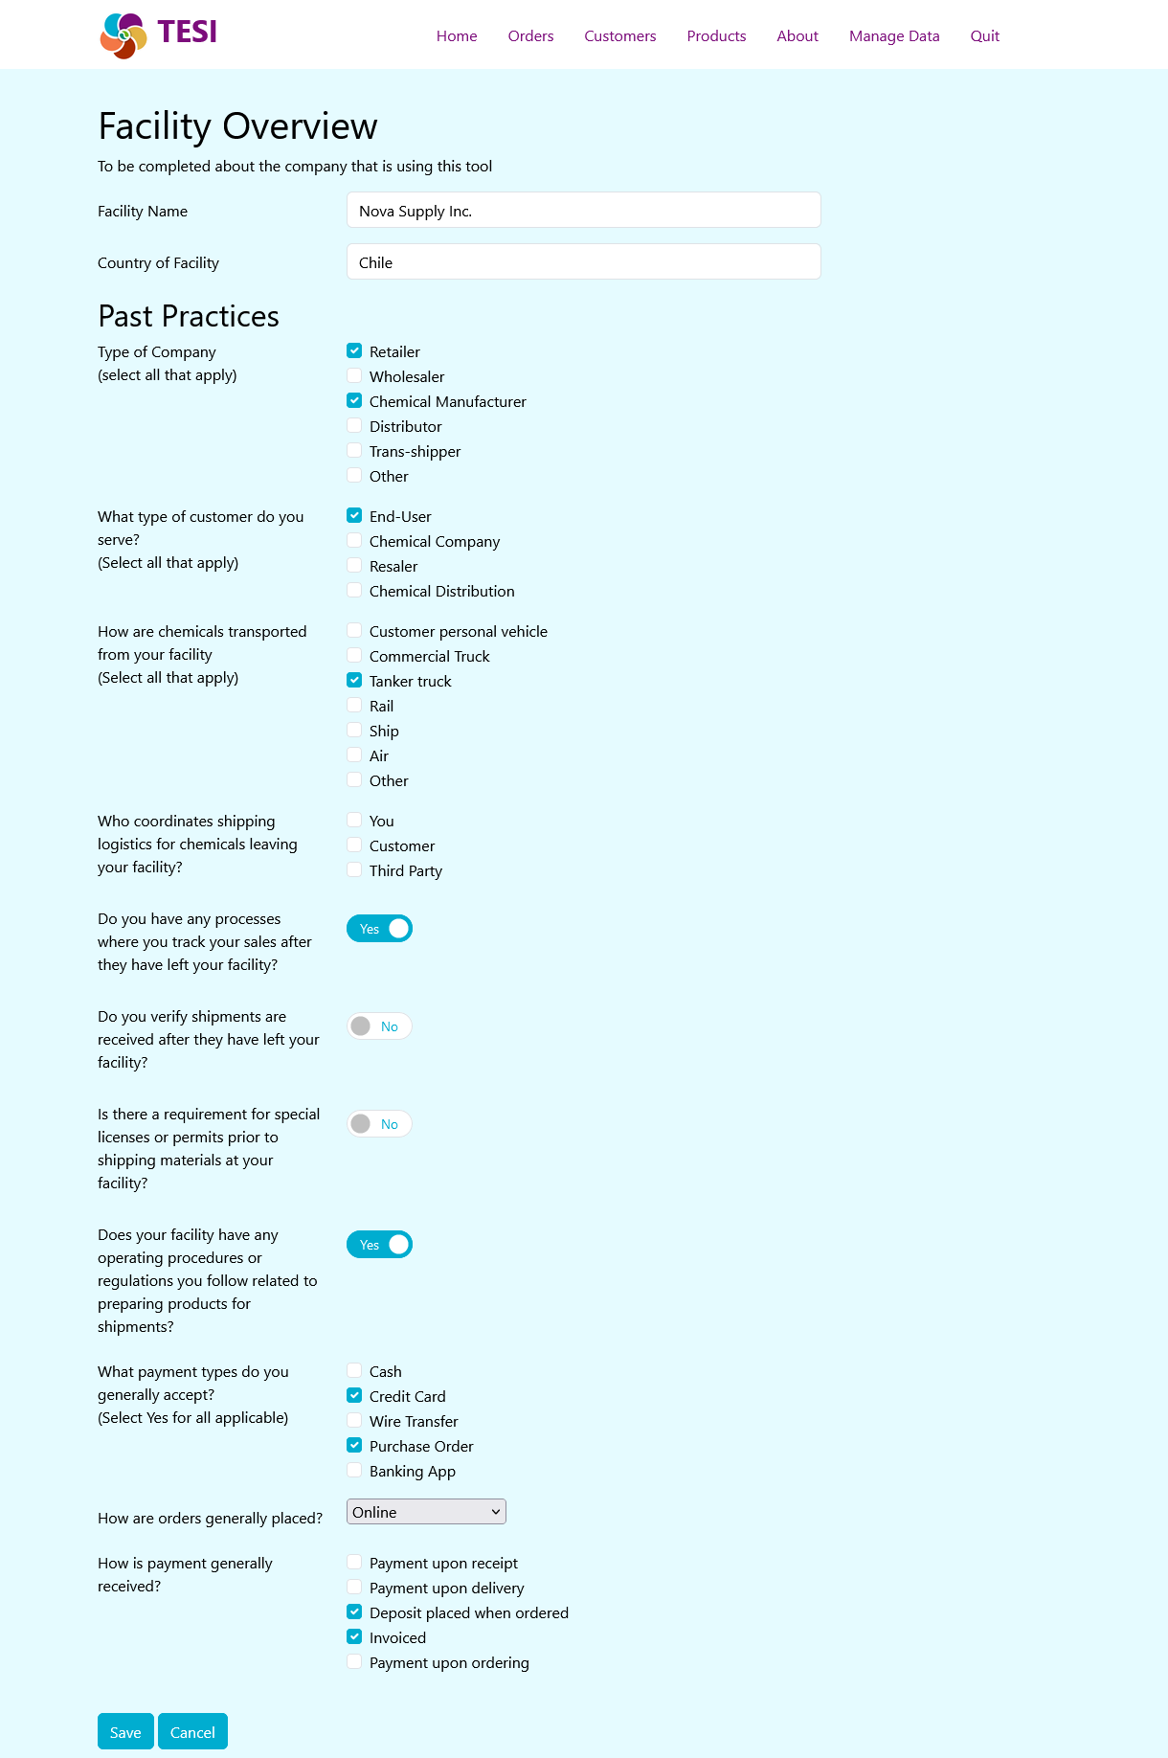

Figure 4. Facility overview page (example)

## Configure Table Displays

There is a variety of fields that may be displayed in the tables for Orders, Customers, and Products. Not all of this information may be needed by the users in a typical day and may be hidden in order to focus on the most relevant information. To configure which columns are displayed for each table, there is a “Select Columns” button above each table. Clicking on the button will display a list of the possible columns for that table and enable the user to toggle on or off the display each one (see Figure 5).

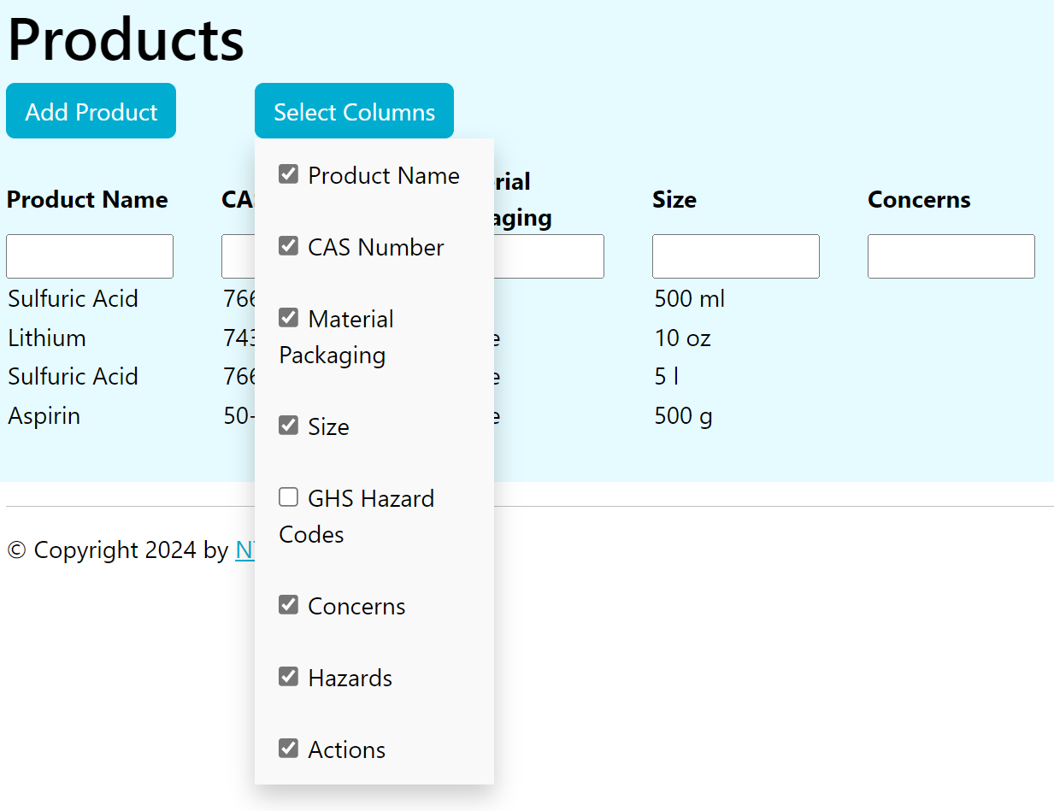

Figure 5. Select columns to be displayed in a table

The column selections will be stored in the browser’s memory and do not need to be reset on each visit. The selections may not be retained if the browser’s cache is reset or if the TESI application is opened in a different browser.

# Orders Icon

## Overview and Basics

The TESI tool collects past orders from customers to allow the users to quickly review past order trends. The “Orders” form is the main page for reviewing all the indicators when making product sales. This page is designed to be used by the sales associate processing the sale to identify any indicators or risks of the product sale. As mentioned before, TESI will provide the indicators, but it is up to the facility to determine the next steps to address the indicators and, ultimately, it is the facility’s decision to proceed with the sale. The “Orders” page can be used to place a new order, view your active orders, or see a list of all orders that have been entered into your system.

### New Order

When you click the “Orders” icon, the “New Order” tab will be the default view. Use this page to enter all of the required information to place a new order.

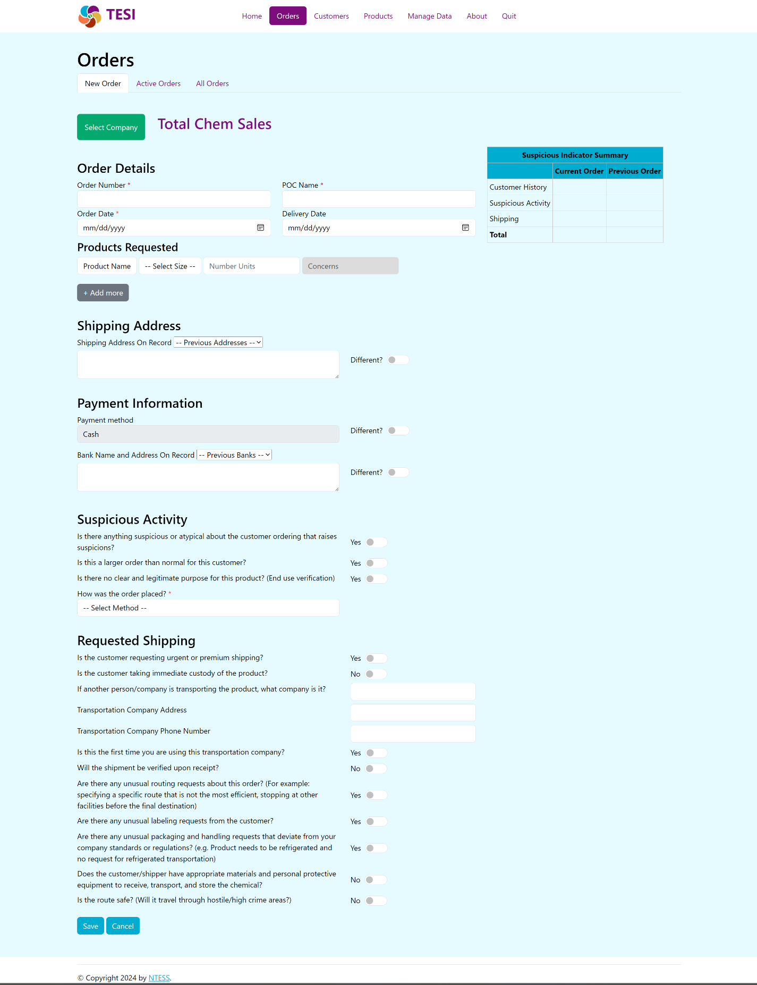

Figure 6. Overview of TESI “New Order” tab on the “Orders” page

#### Select Company

Click the “Select Company” button to choose the correct Customer from the drop-down list. This is a drop-down list that relies on the information from the “Customers” database. The user will then complete the next rows from left to right, using the drop-down list when necessary. Below is a list of information for each column on the customer order.

**NOTE**: If the customer is new or you do not see the company listed, you will need to first add it as a new Customer (see Section 6.1.3), then refresh your “Orders” page and continue.

#### Order Details

* **Order Number**: Enter the order number (according to your company’s numbering system).
* **POC Name**: Enter the name of your primary point of contact (POC) for the order.
* **Date**: Enter today’s date.

#### Products Requested

* **Product Name**: Click on this field to choose from the list of products. If you are ordering more than one product, click the “+Add More” button to create multiple product entries.

**NOTE**: If you do not see the product listed, you will need to add a product (see Section 7.1.3), then refresh your “Orders” page and continue.

* **Select Size**: Field used to indicate the size or quantity for each product in the order.
* **Number Units**: The number of each product in a particular size that is being purchased (e.g., two 1-liter bottles).
* **Concerns**: Indicator field that relies on the information from the “Product Risk Assessment” form and is in the “Products” database. For example, a “Dual-Use” chemical will be flagged as having both commercial and weapons development applications as identified by the Chemical Weapons Convention (CWC).

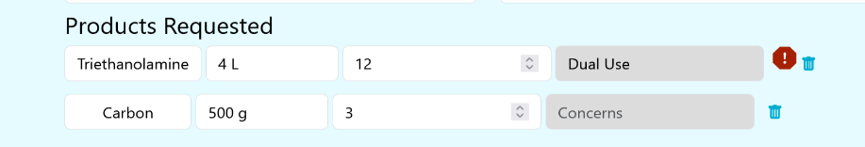

Figure 7. Product hazards flag shown

#### Shipping Address

The information in this section will populate, based on the company you selected for the order and its previous orders. The “Shipping Address On Record” drop-down will be auto-populated with addresses from past orders (if there are any). The address block will be saved for this order and is separate from the address saved in the Customer’s details. The shipping address on record should all be verified with the current order being placed.

* **Shipping Address On Record**: Drop-down shows previously used shipping addresses. The user can select one from the list for the new order.
* **Shipping Address**: The address to use for this order (it may have been selected from the list above or entered manually).

**NOTE**: If an additional, validated shipping address, bank, or payment method differs from previous orders, toggle the “Different?” button to enter the additional information in the corresponding field.

#### Payment Information

Enter the payment information used for the current order. The payment method, bank name, and bank address should all be verified with the current order being placed.

* **Payment method:** How the customer is paying for the order (credit card or wire transfer).
* **Bank Name and Address On Record:** Drop-down shows previously used banks used for payment. The user can select one from the list for the new order or type a new address into the following text area.
* **Bank address**: Name and Address of the bank to be used for this order (may have been selected from the list above or entered manually).

#### Suspicious Activity

Answer the questions listed to determine if a suspicious indicator exists. The “Suspicious Activity” section includes four questions that can be used by the sales associate to evaluate the general behavior and knowledge of the customer with the products in the sale. This section is a judgement or qualitative assessment about the suspiciousness of the specific customer present for the order. The questions are:

* Is there anything suspicious or atypical about the customer order that raises suspicions?
  + This question is based on the opinion of the sales associate. Employee training can be given to improve this judgement based on specific, unusual behavior to look for.
* Is this a larger order than normal for this customer?
  + The sales associate can check past records within the “Orders” form to verify previous order quantities.
* Does the customer have a clear and legitimate purpose for the chemical?
  + This question helps determine if the customer has a real or legal reason to obtain the products. This section may be edited based on the facility needs. One example is to include a list of product uses for the sales associate to choose from and verify with the customer’s claimed use. Employee training can be given to improve this judgement based on specific, unusual responses from the customer.
* How was the order placed?
  + The method the customer made the order (in person, over phone, online).

Companies have prevented the sale of precursor chemicals to adversaries in the past simply by identifying that the buyer was acting suspicious. In the KYC tool, there is a single question reflecting on suspicion that also can be used for oddness in the order itself and not in the behavior: Is there anything suspicious or atypical about the customer ordering that raises suspicions? An orange indicator for this should reflect a need to delay processing and management review of the order. This may also signal a need for external reporting of the order. These actions should align with the company policies and procedures, which are defined outside the KYC tool.

#### Requested Shipping

The last section in the “New Order” form is for Transportation Verification. This section, shown in Figure 8 below, is used to determine how the customer will take ownership of the product, such as shipping or personal pick-up. This may not be appropriate for all companies and can be edited to meet the facility or company needs.

The questions in this section are:

* Is the customer requesting urgent or premium shipping?
  + If this customer is new or does not typically request expedited shipping, it can be an attempt to circumvent standard processes.
* Is the customer taking immediate custody of the chemical?
  + To determine if the customer is using their normal pickup procedures. If the customer usually picks up the product, this may not be a suspicious indicator: however, if this is unusual, this would be considered suspicious and marked with a flag.
* If another person/company is transporting the chemical, who/what company is it?
  + If the answer to the previous question is “Yes”, then this identifies who the transportation company is. This information aids in the due diligence of the transportation provider.
* Transportation Company Address
  + Contact information for the transportation company. This information aids in the due diligence of the transportation provider.
* Transportation Company Phone Number
  + Contain information for the transportation company. This information aids in the due diligence of the transportation provider. Phone contact information can also be important safety information to have.
* Is this the first time you are using this transportation company?
  + Determines if this is a new transporter or a known and trusted transportation company.
* Will the shipment be verified upon receipt?
  + If the customer is using a transportation company, will they verify that the product arrives where it is supposed to go?
* Are there any unusual routing requests about this order? (e.g., specifying a specific route that is not the most efficient, stopping at other facilities before the final destination)
  + These may reflect attempts to bypass legal requirements for transport or allow for diversion/theft during transit.
* Are there any unusual labelling requests from the customer?
  + These may reflect attempts to bypass legal requirements for transport or allow for diversion during transit, especially if border crossings are involved in the transport.
* Are there any unusual packaging requests that deviate from your company standards or regulations?
  + These may reflect attempts to bypass legal requirements for transport or allow for diversion during transit.
* Does the customer/shipper have appropriate materials and personal protective equipment to receive, transport, and store the chemical?
  + This helps determine if the customer has a legitimate purpose for the product. If they cannot safely handle the product, they may not intend to use it for the stated purpose.
* Is the route safe? (Will it travel through hostile/high crime areas?)
  + This determines if the product is more likely to be stolen during transit.

Each company will need to determine actions to take for any orange indicators highlighted in the transportation section. It is recommended that orange indicators in the transportation section require additional review and are reported to management before an order is processed. This may also signal a need for external reporting. These actions should align with the company’s defined policies and procedures before using TESI. These indicators reflect uncertainty in the transaction and based on defined procedures, may delay processing until questions can be answered by the customer.

#### Completing a Customer Order

Once the three sections of the “New Order” form are completed, the facility or company can analyze the indicators present for the specific order and determine whether to proceed with the sale. A completed example form is shown in Figure 8 for AC Chemical Traders.

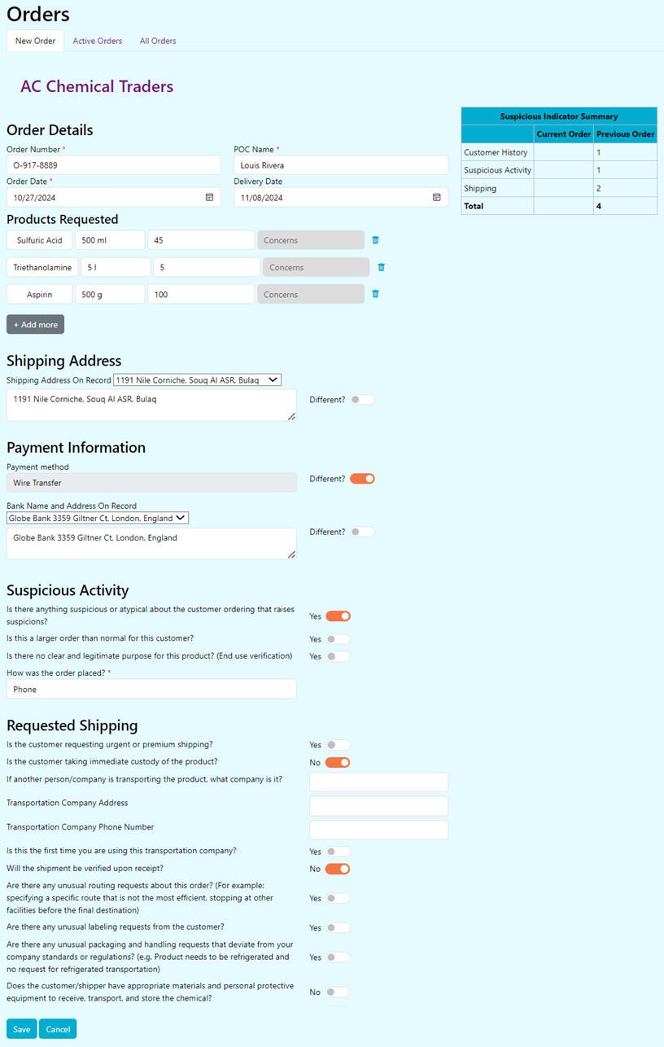

**Requested Shipping**

**Suspicious Activity**

**Shipping Address and Payment Information**

**Order Details and Products Requested**

Figure 8. Completed Customer Order tab (example)

For the order represented in Figure 8, there are multiple concern flags that should be reviewed before the order proceeds. The indicators are as follows:

* **Order Details and Products Requested:** One caution flag indicating one of the products is a dual-use chemical and could pose a risk. This alone should not stop a transaction, but it does mean that the customer and transportation should be verified.
* **Shipping Address and Payment Information:** One orange flag indicating the payment method has changed from past actions.
* **Suspicious Activity:** One orange flag indicating the customer acted in a suspicious manner. This combined with the hazardous chemicals may begin to make a company question whether to proceed with the sale.
* **Requested Shipping:** Two orange flags show the customer is not taking immediate custody of the product and they will not be verifying the receipt of the product upon arrival.

Some orange indicators can be addressed by contacting the customer company POC (when applicable) to verify any changes to address, payment, shipping, and ordering trends. Ultimately, it is up to the facility to decide on the level of escalation required for each order and whether to proceed with the transaction.

After the transaction is completed, click “Submit” to transfer the order to the “Ordering Database” worksheet and clear the screen for the next transaction.

### Active Orders

When you click the “Active Orders” tab at the top of the page, you will get a list of all open/pending product orders.

* **Date**: Date the transaction was made.
* **Order ID**: Internal TESI identification number of the order.
* **Order Number**: Company defined order number for each transaction.
* **Customer Name**: Customer (business) who made the transaction.
* **Telephone**: Lists the telephone number of the main POC.
* **POC Name**: Individual representative from the customer who made the transaction.
* **Number Units:** How many of each quantity of material was sold in the transaction.
* **Suspicious Indicators**: Tally of the number of orange flags found in the order.
* **Shipping Address**: Address to which each order is to be shipped.
* **Actions**: Buttons to edit or delete each order.

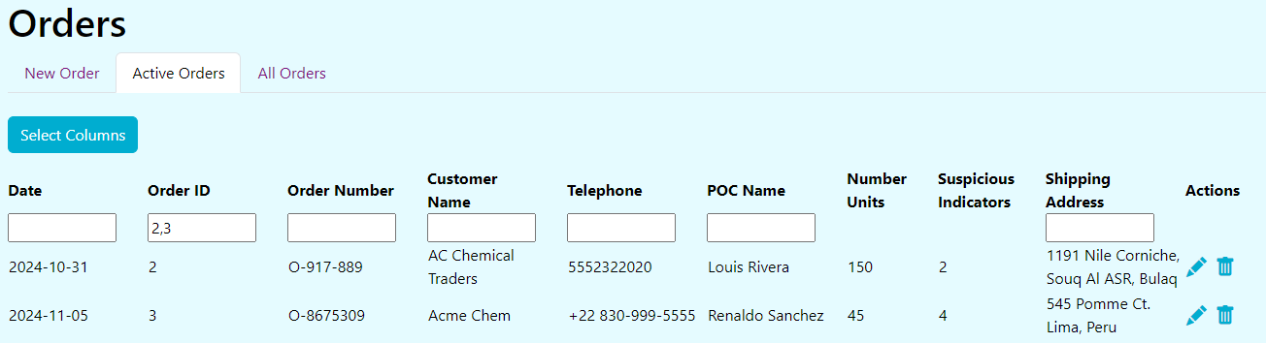

Figure 9. Screenshot of "Active Orders" tab on Orders page

#### Filtering your Orders View

Use the search fields under each column heading to filter your list. You may filter on multiple columns.

### All Orders

Clicking the “All Orders” tab will show a complete list of all orders in the system. The columns on this page are the same as the “Active Orders” page (see Section 5.1.2).

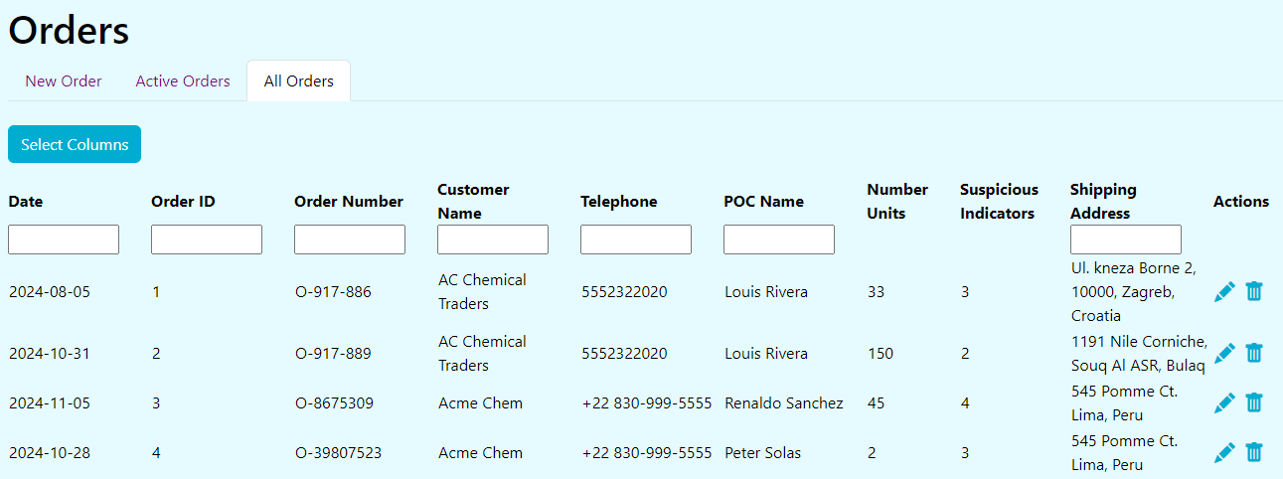

Figure 10. Overview of TESI “All Orders” tab on Orders page

### Edit an Order

Click the pencil icon to edit the details for any existing orders.

### Delete an Order

Click the trash can icon to delete an order.

# Customers Icon

## Overview and Basics

A customer identification program is an early component of KYC. In addition to collecting customer information, KYC best practices include the verification of the customer information and tracking any abnormalities. The “Customers” icon provides an interface for accessing the customer database and adding new customers through the “Customer Verification” form. The Customer database contains both the business information of customers as well as their provided bank information (under “Financial Verification”). A quick look at the navigation options and features on the Customers page is presented in Figure 11.

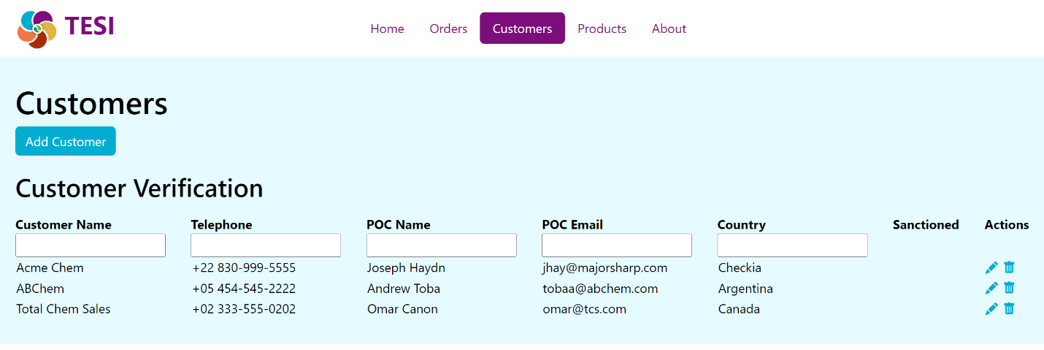

Figure 11. Overview of the TESI Customers page

### Customer List

The Customers Page will display a list of all companies in the system with the following information:

* **Customer Name**: This column displays the company (customer) name
* **Telephone**: Lists the telephone number of the main POC
* **POC Name**: Lists the name of the main POC
* **POC Email**: Lists the email address for the main POC
* **Country**: The country in which the company is located
* **Sanctioned**: Displays whether the customer has been marked as a sanctioned entity
* **Business Number**: Business’s operating license or tax number
* **Verification Date**: Date the customer’s information was last checked
* **Payment Method**: The typical way this customer pays for orders

### Filter Customer List

You can enter text into the fields under each data column to filter the customers displayed. The filter will accept partial matches. Filter criteria can be applied in multiple columns simultaneously to further limit the results. The results must match all applied filters. To undo a filter, simply remove the text from the search box. In Figure 12 below, typing “Chemical” into the “Customer Name” column filter box reduced the list to two results, and typing “Ar” into the “Country” filter further reduced the results to one row.

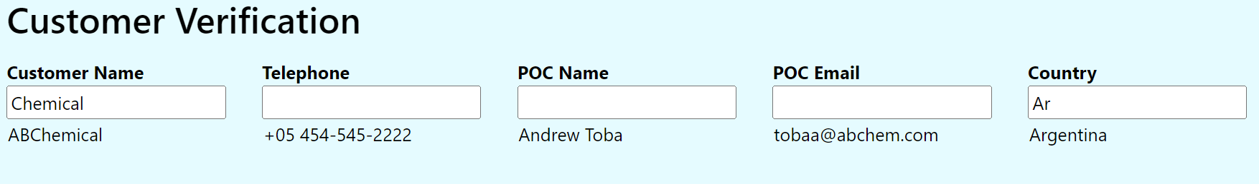

Figure 12. Filtering the TESI Customer Database view

### Add Customer to Database

When you click the “Add Customer” button, you will be required to enter information into multiple fields. Customer verification reduces the risk of products falling into the hands of someone with malicious intent. The objective is to ensure the customer is legitimate and will not use dual-use chemicals in an illegal manner.

The process for customer verification should align with the risks associated to the company and associated with the product. For most products being sold by small-to-medium sized companies, the verification process can focus on verification of addresses, payment processes, and name. More robust processes can include a detailed background screening of the customer and/or third-party verification. In addition to aligning with risks, the customer verification process may be limited or guided by specific legal requirements or standards.

TESI is focused on a simplified process for customer verification, shown in Figure 13. This form is designed to be used by the customer sales associate or other any employee who would collect new customer information. TESI includes a variety of questions to collect information on the customer. It is recommended that the facility review the questions and determine the applicability and accuracy for their business model and type of customer. See Figure 14 below for a full view of the new customer form.

#### Customer Verification

* **Name of Customer/Business**: Customer name (may be a person or a purchasing company, facility, or institution).
* **Telephone**: Telephone number to reach the customer or the primary POC at the business.
* **POC Name**: If a business is the customer, this field is optional to identify the primary POC and/or authorized purchasers for the business.
* **POC Email**: Email address to reach customer.
* **Customer Number:** Your business’s tracking number or ID for each customer (for cross-reference with other systems).
* **Country**: Country where the ordering company headquarters is located.
* **Address**: Physical location of the customer or facility of the business. This is used in TESI to determine if a shipment is being sent to the same location. If the customer or business has multiple legitimate locations, the user will need to modify the database to track this information.
* **Proof of Address**: How the “Street Address” is verified (if necessary). A variety of options are given.
* **Proof Accepted**: Indicator field for address verification. Selecting “Yes” will confirm the location as accurate.
* **POC Date of Birth**: This can be used to confirm the identity of the POC in subsequent transactions.
* **POC Nationality**: This field is the nationality of the POC placing the order.
* **POC Father's name/Mother's name**: This field is an optional field for higher security verification to confirm the identity of the “Point of Contact” for transactions determined by the user as high-risk.
* **Business Number**: Government-issued unique identification number for company. Documentation and verification of the authenticity is highly recommended.
* **Business Type**: Type of business the customer operates. Examples of a few selections include distributor, end-user, or retailer. This field is used to understand the customer and anticipate the typical business relationship and sales trends. This field can be used to highlight abnormal sale trends and can also be used to verify that the business type matches the government-issued license.
* **Trusted Customer**: If this customer is known and has previously been verified according to business number and/or other standards.
* **Verification Date:** Date the customer’s information was last checked.
* **Third-party reference name**: Optional field to collect third-party references for the customer/business. This helps ensure the customer has a legitimate need for the chemical, based on a third-party confirmation. The reference could be another vendor, a customer of the customer, or a collaborator of the customer with whom legitimacy is well known.
* **Third-party reference contact information**: This field should include the primary contact information for the third-party reference.

**NOTE**: Place of birth, parent’s names, nationality, and other types of information used for identification purposes are considered Personally Identifiable Information and should be protected in accordance with relevant regulations and best practices.

#### Financial Verification

* **Bank Names**: Name of the financial institution or bank for payment.
* **Bank Addresses**: Location of the bank listed in the “Bank Name” field.
* **Payment Method**: How the customer is making their purchase. Cash or crypto currency payments are not guarantees of illegitimate purchases, but requests for this type of payment are considered higher risk. This may be dependent on the company’s normal business practices and cultural norms in the region. In areas or industries where cash payments are common, these do not raise the same suspicions.
* **Frequency of Ordering**: Optional field used to understand customer purchasing trends.
* **Company or financial institute on any sanctioned list?**: It is highly recommended that the user review applicable sanctions list to verify that neither the customer, business name, or financial institution appear on them.

Click “Save” when done entering all of the new customer’s information or click “Cancel” to clear the form.

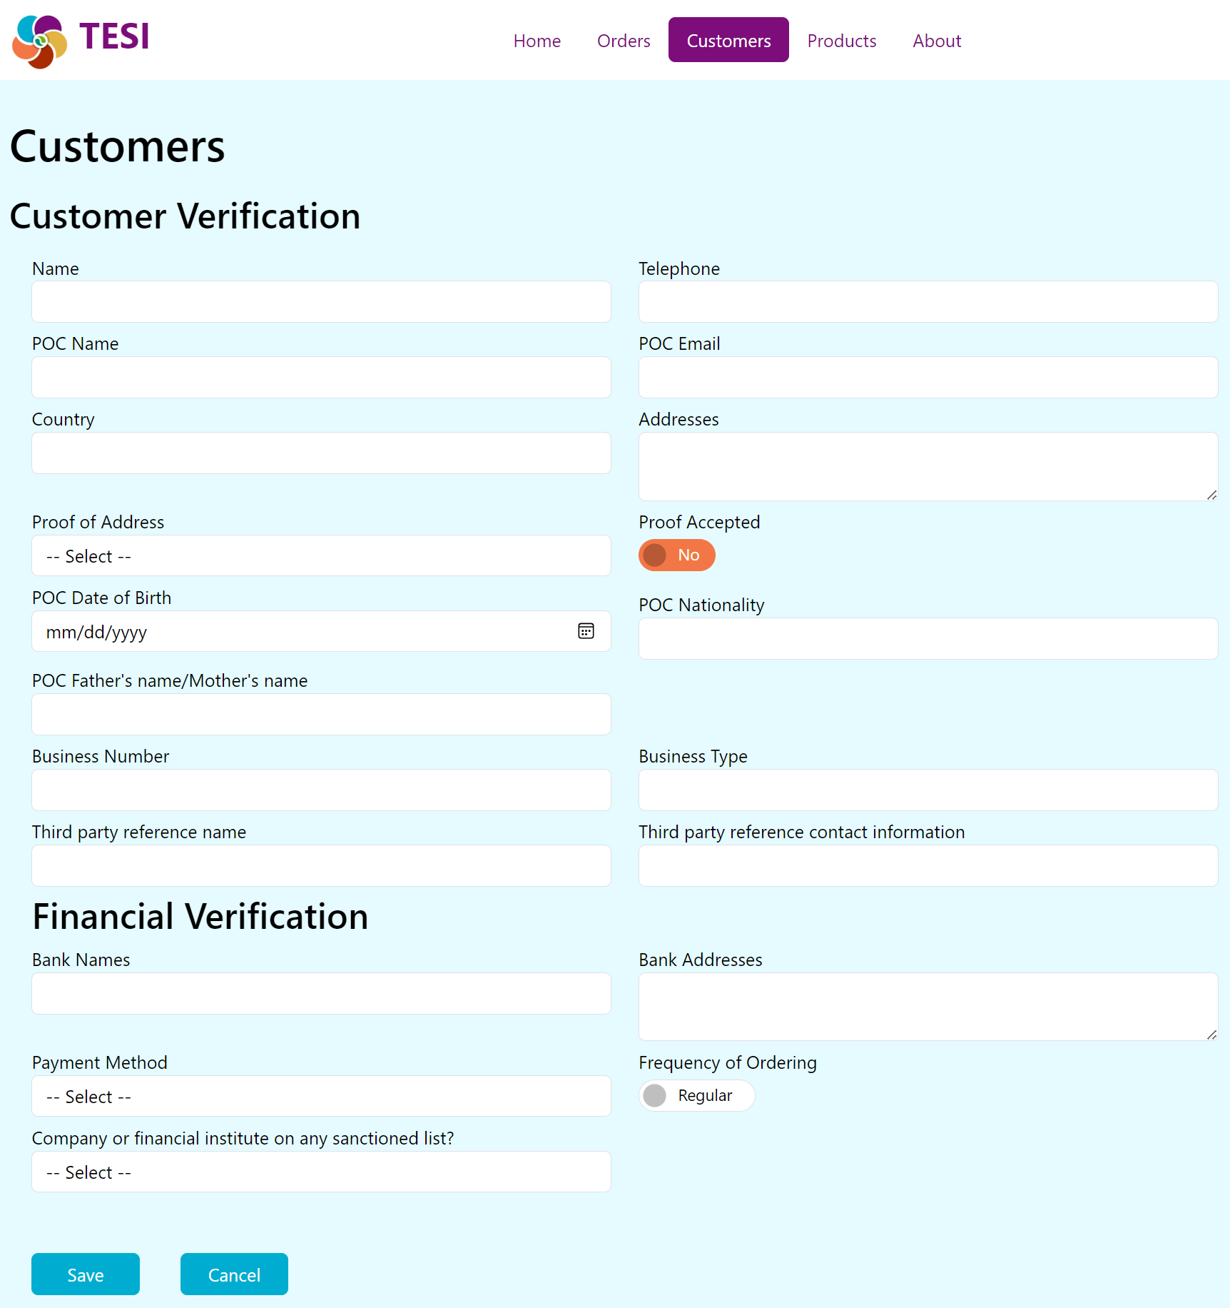

Figure 13. Overview of the TESI Customer Verification form for adding new customers

### Sanctioned Entity Matches

Whenever a customer's name or address is saved, or if a bank name of address is saved, TESI searches an internal database of internationally sanctioned entities with matching information. TESI’s internal database was preloaded with lists of sanctioned entities. For more information about the pre-loaded lists, see Sanctions Lists (in the Appendix). If information you entered for the customer or their bank matches any records in the sanctioned entities database, you will be notified with a dialog listing the matches as shown in Figure 14 below.

In the dialog, you will be given the option to confirm the entity as Sanctioned (as a business or individual that appears to be sanctioned). Clicking the “Confirmed Sanctioned” button will update the Name/Address record in the database with a “Sanctioned” flag. Alternatively, clicking the “Close” button will dismiss the notification without updating the record.

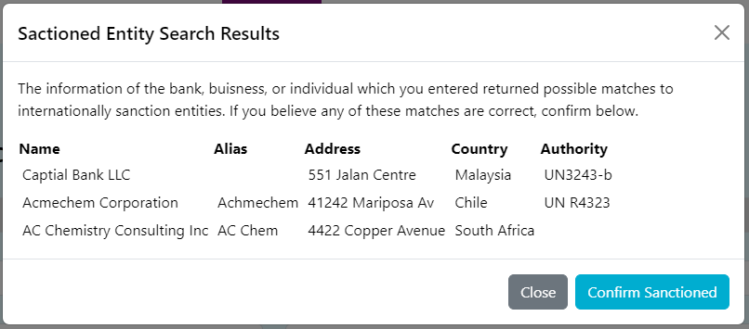

Figure 14. Sanctioned Entities dialog box

### Edit Customer Form

To edit existing customer information, a user can click the pencil icon under the “Actions” column in the customer’s row. This will open up the Customer Verification form and allows you to edit the fields (see Section 6.1.3 for the full list of fields).

### Delete Customer from Database

To delete a customer from the TESI database, click the Trash icon on the right-hand side of the customer’s row. A dialog box displays, asking the user to confirm the deletion. Click “OK” to proceed with the deletion or “Cancel” to exit.

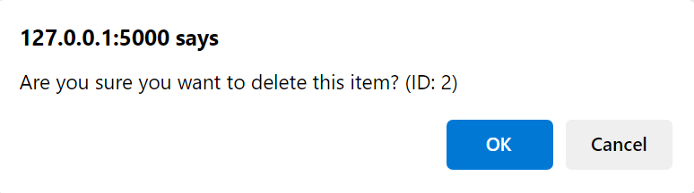

Figure 15. Delete Customer dialog box

# Product Icon

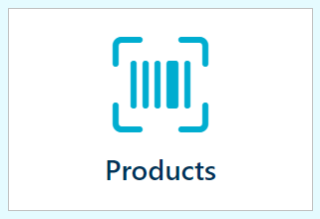A key step in understanding the risks of the products you sell begins with knowing what products you have and the hazards or risks inherent to those products. TESI supports this by including a product risk assessment form to help identify products with potential dual-uses and provides a product database as a tool to manage your product inventory.

Clicking on the TESI “Products”icon takes the user to the products database. Additional products may be added to the catalog per Section 7.1.1. Products may also be imported to the list from another system, as described by in Section A.2.

## Overview and Basics

Click the “Products” tile and a list of products appears on the page. Below is a quick overview of the basic features and buttons on the Products Page.

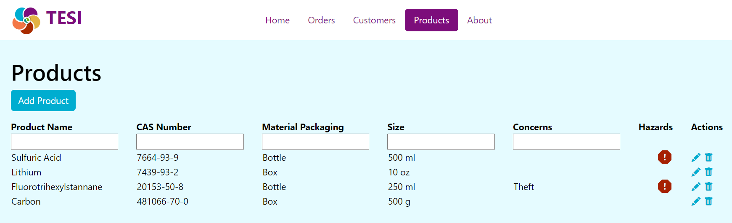

Figure 16. Overview of the TESI Products page

### Products Page View

This table includes the list of products entered in the “Product Risk Assessment”. The “Hazards” column has a red icon () if the GHS codes (Globally Harmonized System of Classification and Labelling Chemicals) entered in the “Product Risk Assessment” form have a red indicator. This will appear as a red indicator on the Customer Order tab. Your facility can manually edit this field based on its decision of the hazardous rating for a product. Additionally, if your company already has product information, you can directly add the information to this database.

### Filter Product Database

From the Products Page, you can enter information into the search boxes under each column heading to filter your results. You can filter on multiple columns, if desired.

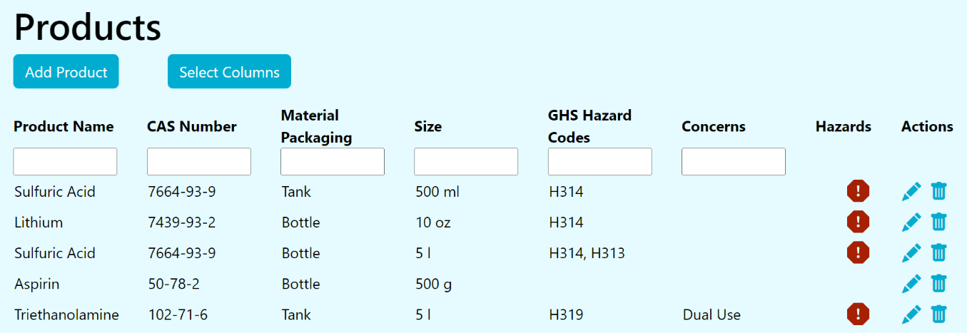

Figure 17. Action buttons on Products page

### Adding a New Product

Click the “Add Product” button to create a new product. For each product that is sold, the company will need to complete the information in the “Product Risk Assessment” form to determine the hazards and risks of the products. This page is designed to be completed by a person at the facility that is knowledgeable about the products, such as the facility’s management or Safety and Security Officer. This page should be filled out prior to a customer sale and is used to populate the “Product Inventory” worksheet. Information about chemicals can be found in a variety of places. For example, chemical hazards can be found on a Safety Data Sheet (SDS) provided by the product manufacturer or searched online at [PubMed](http://ttps://pubmed.ncbi.nlm.nih.gov/) and the [Europeans Chemicals Agency](Europeans%20Chemicals%20Agency) (ECHA) website. Known security concerns related to a chemical can be found on various international lists such as The Australia Group, OPCW, and Wassenaar Arrangement (See A.3, Definitions for more details). The Product Risk Assessment worksheet (shown in Figure 18 below) includes a variety of sections to be completed. This worksheet can be redesigned to meet the facility’s needs. The current worksheet includes nine sections initially designed for a chemical product risk assessment.

The page contains the following fields:

* **Product ID**: How the product is identified by the company for inventory purposes; this may be letters, numbers, or combination of letters and numbers.
* **Product**: The name of the product as it will be sold to customers (e.g., Chlorine, Window Cleaner).
* **CAS Number**: The CAS number for ALL chemicals found in the product. A CAS number is a numeric identifier that is unique for a chemical and may contain up to 10 digits. For example, caffeine has a CAS number of 58-08-2. CAS numbers may be found by doing a search at <https://commonchemistry.cas.org> (if you know the name of the chemical). If you do not find the chemical there, you can sometimes find it by doing a general internet search. CAS numbers can also be found in SDS sheets from the manufacturer of the chemical or mixture. CAS numbers should be put into TESI without dashes (for example, caffeine would be put in as 58082 for CAS 58-08-2) and multiple CAS numbers can be entered, with a comma separating each CAS. An orange flag indicates that a chemical in the product is identified as a potential dual-use chemical due to inclusion on chemicals of concern lists by the CWC or the Australia Group.
* **Physical State**: Solid, liquid, or gas.
* **Packaging**: The product packaging (e.g., amber glass bottle, plastic bottle, etc.).
* **Size**: The quantity the product is sold as (e.g., 1 L, 2 kg, etc.).
* **GHS Hazard Codes**: GHS Codes are part of the Globally Harmonized System of Classification and Labelling Chemicals and provide a set of standardized phrases that relate to hazards associated with a chemical. Each GHS code is the letter H followed by a three-digit number. For example, H200 indicates Unstable Explosive and H300 indicates Fatal if Swallowed. This information can be found on the SDS or at PubMed for a given chemical. Indicators in this section identify chemicals that can cause damage to people or the environment. Many chemicals have more than one GHS code and all the GHS codes for a chemical mixture should be entered. The table below shows the GHS H-codes and corresponding hazard statements that will display a red flag.

Table 1. GHS H-codes

|  |  |  |  |  |
| --- | --- | --- | --- | --- |
| Code | Hazard Statement |  | Code | Hazard Statement |
| **H204** | Fire or projection hazard |  | **H282** | Extremely flammable chemical under pressure: may explode if heated |
| **H206** | Fire, blast or projection hazard; increased risk of explosion if desensitizing agent is reduced |  | **H300** | Fatal if swallowed |
| **H207** | Fire or projection hazard; increased risk of explosion if desensitizing agent is reduced |  | **H301** | Toxic if swallowed |
| **H209** | Explosive |  | **H310** | Fatal in contact with skin |
| **H210** | Very sensitive |  | **H311** | Toxic in contact with skin |
| **H220** | Extremely flammable gas |  | **H314** | Causes severe skin burns and eye damage |
| **H221** | Flammable gas |  | **H318** | Causes serious eye damage |
| **H224** | Extremely flammable liquid and vapor |  | **H330** | Fatal if inhaled |
| **H225** | Highly Flammable liquid and vapor |  | **H331** | Toxic if inhaled |
| **H228** | Flammable solid |  | **H370** | Causes damage to organs |
| **H230** | May react explosively even in the absence of air |  | **H400** | Very toxic to aquatic life |
| **H232** | May ignite spontaneously if exposed to air |  | **H401** | Toxic to aquatic life |
| **H240** | Heating may cause an explosion |  | **H410** | Very toxic to aquatic life with long lasting effects |
| **H250** | Catches fire spontaneously if exposed to air |  | **H411** | Toxic to aquatic life with long lasting effects |
| **H260** | In contact with water releases flammable gases which may ignite spontaneously |  | **H271** | May cause fire or explosion; strong Oxidizer |
| **H261** | In contact with water releases flammable gas |  |  |  |

* **Other Issues of Security Concern**: Any additional concerns may be placed here, which the company may consider outside the scope of chemical control lists or GHS codes. For example, enter any additional security concerns you may have about a chemical (e.g., if there is a history of theft for a given chemical in your region).
* **Concerns**: If there are any flags, this should be Yes; otherwise it should be No.

See Figure 18 for a screenshot of the New Product page.

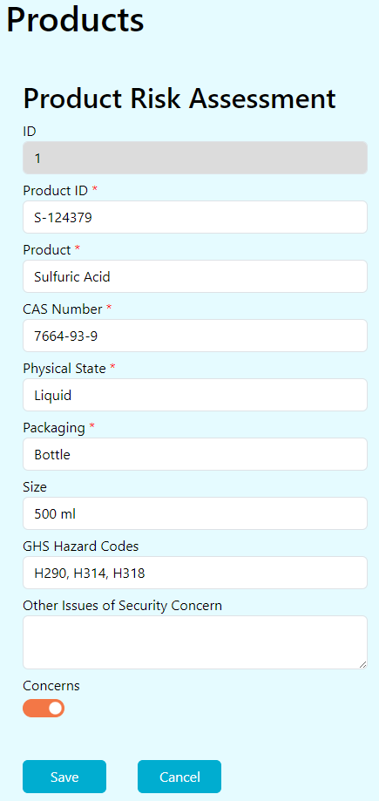

Figure 18. Example of a filled-out Product form

### Edit a Product

Click the pencil icon under the “Actions” column to edit the details for any product.

### Delete a Product

Click the trash can icon under the “Actions” column to delete a product. A dialog box will appear, asking you to confirm the deletion. Click “OK” to delete or click “Cancel” to exit.

# Interpretation of Results

The process flow for the TESI tool can be seen in Figure 19 below. The goal is to make an informed decision about whether to proceed with a sale based on information on the product being sold, the customer purchasing it, and how it is to be transported. The “Product Risk Assessment” and “Product Inventory” worksheets provide information on hazards related to the product, the “Customer Verification” and “Database” worksheets provide information on the customer purchasing it, and questions within “Customer Order” provide information on how it will be transported. All are important to understand the risks of a sale.

Once all the information has been gathered and put into the tool, a quick analysis can be made about the number of orange indicators. Decisions can be then made to complete a transaction or to follow-up with questions before determining whether to complete a transaction.

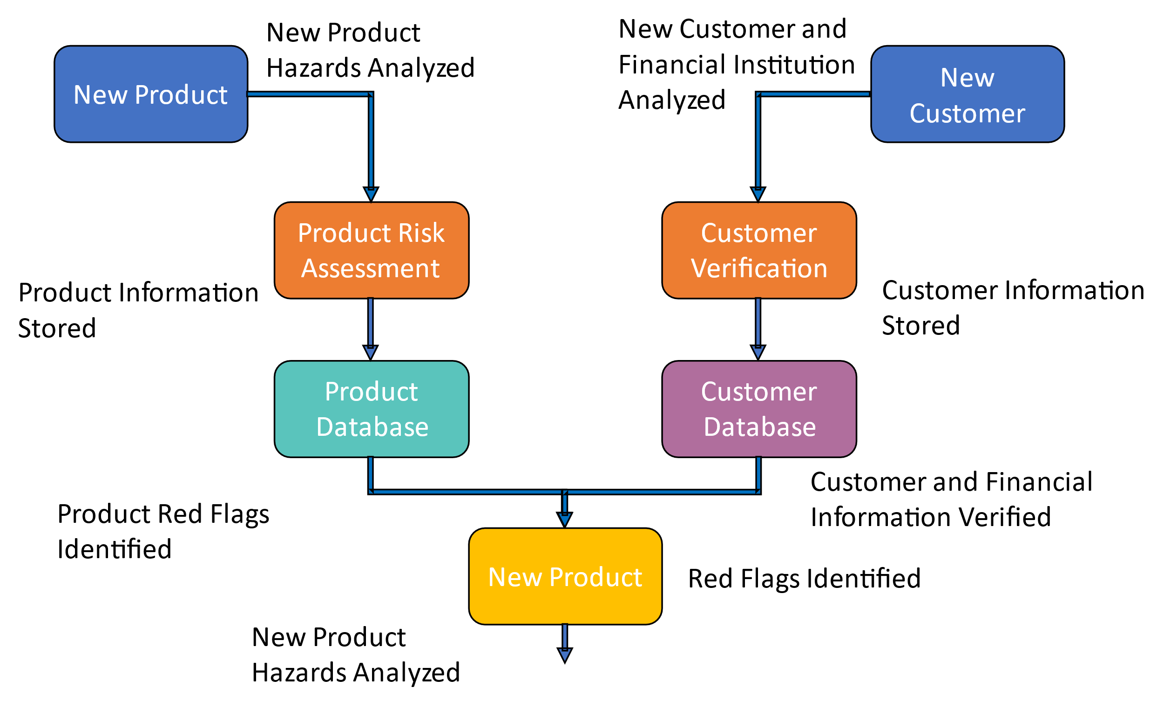

Figure 19. KYC Tool process flow diagram

## Transaction Analysis Example

This section provides an example method of combining each indicator to determine the risk of the transaction. Below is a 3-step accumulation of indicators to highlight the level of risk from low to high.

Step 1: Begin with the “Customer Verification”, which includes first determining if the customer is new or existing.

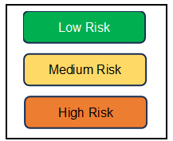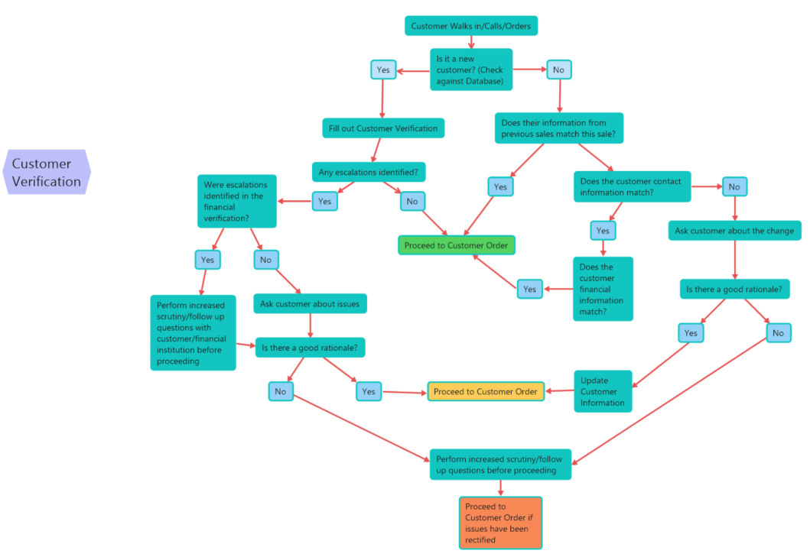

Figure 20. KYC Tool Customer Verification process flow diagram

Step 2: Evaluate the Customer Order. The blue boxes pull in the information highlighted in Step 1 which may raise or lower the accumulated risk for the transaction.

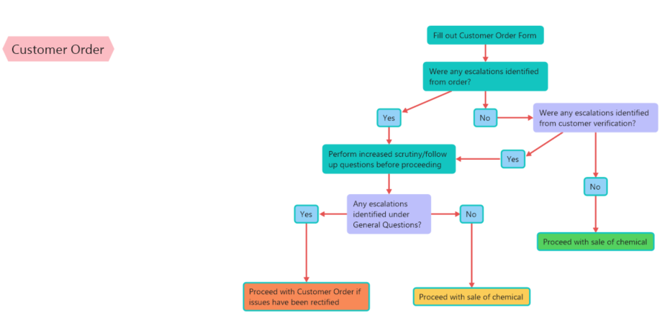

Figure 21. KYC Tool Customer Order process flow diagram

Step 3: Evaluate the shipping method for the transaction. As with Step 2, the blue color boxes pull in the information highlighted in Step 1 which may raise or lower the accumulated risk for the transaction.

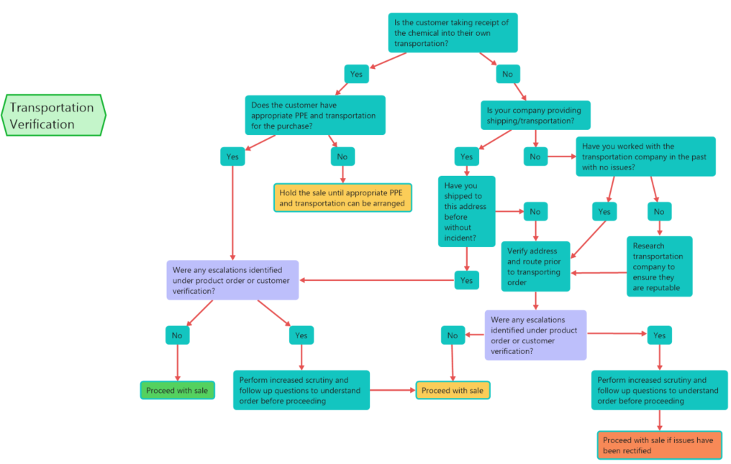

Figure 22. KYC Tool Transportation Verification process flow diagram

1. Technical Information and References
   1. Exporting Data from TESI

The TESI Export function (in Manage Data) can be used to export Product, Customer, and Order data from the TESI database to an Excel, CSV or JSON file from TESI. This section provides descriptions of this process for exporting an Excel file directly from the TESI database, but the process is the same for exporting the CSV or JSON file.

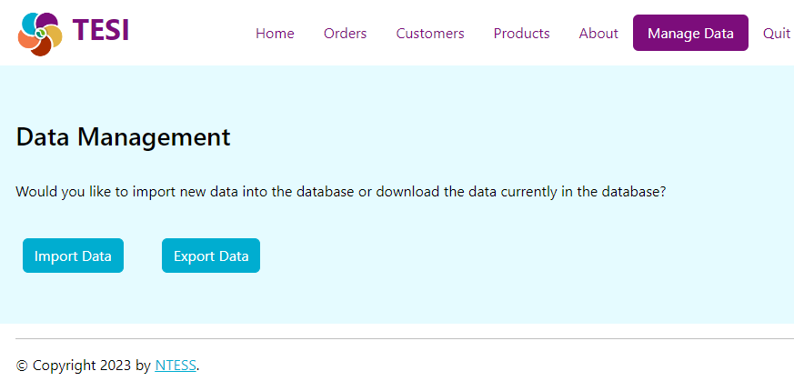

Figure 23. Manage Data Import/Export menu

1. Click the Export Data button.
2. Choose the data set you wish to export (Products, Customers or Orders).
3. Choose the file format you wish to use (Excel, CSV, or JSON).
4. Click the Download Data button.

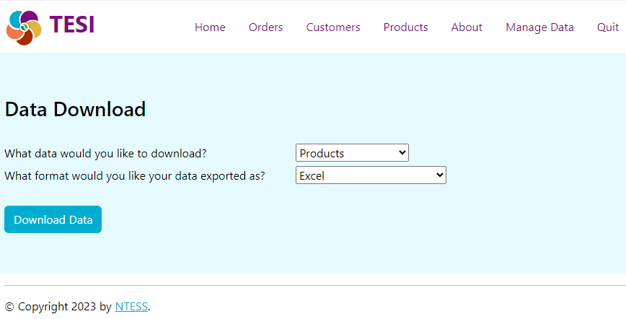

Figure 24. Export data options

* 1. Importing Data into TESI

The TESI Import function (in Manage Data) can be used to import Product, Customer, and Order data into the TESI database from Excel (.xlsx, .xls, .xlsm file types), CSV or JSON files. This section provides a description of this process for importing data from an Excel file, but the process is the same for importing CSV or JSON files.

**For the "products" table, the input column headers in Excel need to be:**

* CAS Number: String
* Concerns: TRUE/FALSE
* Facility Product ID: String
* Hazard Codes: Comma separated strings (e.g., H313,H314)
* Material Packaging ID: Number
* Other Issues: String
* Physical State ID: Number
* Product Name: String
* Size: String (e.g., 35 L)

**For the "customers" table, the input column headers in Excel need to be:**

* Address Proof Accepted: TRUE/FALSE
* Address Proof Type ID: Number
* Bank Address : String
* Bank Name: String
* Business Number: String
* Business Type: String
* Country: String
* Customer Address: String
* Customer Name: String
* Facility Customer ID: String
* Order Frequency: TRUE/FALSE
* Payment Method ID: Number
* POC Date of Birth: mm/dd/yyyy
* POC Email: String
* POC Name: String
* POC Nationality: String
* POC Parent Name: String
* Sanctioned: Number (e.g., 1 = Yes, 2 = No, 3 = Unknown)
* Telephone: String
* Third Party Contact Information: String
* Third Party Ref Name: String
* Trusted Customer: TRUE/FALSE
* Verification Date: mm/dd/yyyy

**For the "orders" table, there should be a separate row for each product ordered. New products (identified by an unrecognized facility_product_id) will automatically be added to the Product table. The input column headers for “orders” in Excel need to be:**

* address_different: Boolean
* atypical_order: Boolean
* bank_address_different: Boolean
* bank_name_different: Boolean
* cas_numbers: String
* concerns: Boolean
* customer_id: Number
* delivery_date: mm/dd/yyyy
* end_use_verified: Boolean
* facility_order_id: String
* facility_product_id: String
* first_time_transporter: Boolean
* hazard_codes: String
* immediate_custody: Boolean
* larger_order: Boolean
* name: String (i.e., the name of the product/chemical)
* order_bank: String
* order_date: mm/dd/yyyy
* order_method: Number
* other_issues: String
* packaging: Number
* payment_different: Boolean
* payment_method_id: Number
* physical_state_id: Number
* poc_name: String
* ppe_concern: Boolean
* quantity: Number
* route_safety_concern: Boolean
* shipment_verification: Boolean
* shipping_address: String
* size: String (e.g., 500 ml)
* transporter_address: String
* transporter_name: String
* transporter_phone: String
* unusual_handling: Boolean
* unusual_labeling: Boolean
* unusual_routing: Boolean
* urgent_shipping: Boolean

To Import a data file:

1. Click the Import Data button shown in Figure 23 above.
2. Select the data set type and the file to be imported.
3. Click the Import Data button.

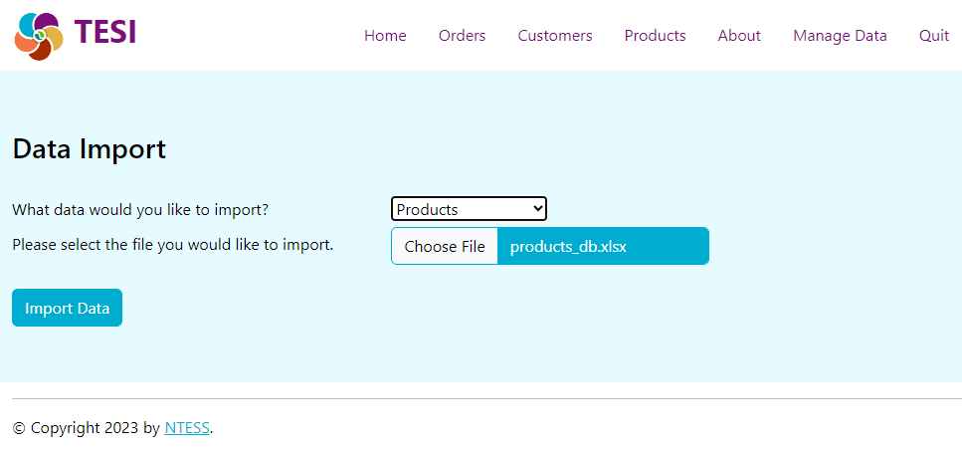

Figure 25. Import data options screen

If the fields in the imported file do not match the expected fields, an error message explaining the issue will be displayed (example below).

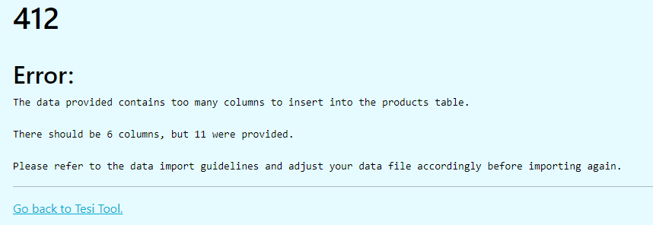

Figure 26. Import data error message example

* 1. Definitions

| Term | Definition |
| --- | --- |
| ABOUT ICON | The “About” icon includes information regarding the version of TESI software being used and the license agreement. |
| CHEMICAL ABSTRACT SERVICE REGISTRY NUMBER (CAS RN) | Chemical Abstract Service Registry Number is also referred to as CAS Number or CAS #. This unique numeric identifier can contain up to 10 digits assigned to one unique chemical substance and is separated into three groups by hyphens. Starting from the left, the first part of the number has two to seven digits; the second part has two digits. The final part consists of a single check digit. The check digit, generated by a standard calculation, can be used to verify the CAS validity. All chemical substances registered with CAS are assigned a CAS Number. The CAS Registry—containing more than 71 million organic and inorganic substances and 64 million sequences—is the most authoritative collection of disclosed chemical substance information. For more information on the standard calculation and how to validate the CAS number, and to search CAS Numbers, visit <http://www.cas.org/>. |
| CWC | The Chemical Weapons Convention (CWC) (implemented by the Organisation for the Prohibition of Chemical Weapons [OPCW]) aims to eliminate an entire category of weapons of mass destruction by prohibiting the development, production, acquisition, stockpiling, retention, transfer, or use of chemical weapons by States Parties. States Parties, in turn, must take the steps necessary to enforce that prohibition in respect of persons (natural or legal) within their jurisdiction. All States Parties have agreed to chemically disarm by destroying any stockpiles of chemical weapons they may hold and any facilities which produced them, as well as any chemical weapons they abandoned on the territory of other States Parties in the past. States Parties have also agreed to create a verification regime for certain toxic chemicals and their precursors (listed in Schedules 1, 2 and 3 in the Annex on Chemicals to the CWC) in order to ensure that such chemicals are only used for purposes not prohibited. Therefore, any chemical on the CWC List must be managed and controlled by all signatories to the CWC. Even for non-signatories, the chemicals on the list are important to track and secure. To find out more information about the CWC, please visit <http://www.opcw.org/chemical-weapons-convention/>. If the website link is broken, conduct an internet search for “OPCW CWC.” |
| Dual Use | Chemicals, equipment, knowledge, or software that can be used for legitimate purposes or misapplied to manufacture illicit drugs, explosives, or chemical weapons that pose a threat to public health and safety, agricultural crops, the environment, or national security.  **Note:** The Organisation for the Prohibition of Chemical Weapons uses the term “multi-use” to express the same concept (<https://www.opcw.org/multiple-uses-chemistry>). |
| GHS | Globally Harmonized System of Classification and Labeling of Chemicals, a framework that standardizes the classification and labeling of chemicals worldwide. Its goal is to establish criteria for the classification of health, physical and environmental hazards, and specify what information should be included on hazard labels as well as safety data sheets. As a global standard, GHS encourages individual countries to implement hazard classes and categories in their legislation. For more information, please visit <https://chemicalsafety.com/globally-harmonized-system-ghs/#:~:text=GHS%20is%20an%20acronym%20for%20the%20Globally%20Harmonized%20System%20of>. |
| Organisation for the Prohibition of Chemical Weapons (OPCW) | The implementing body for the Chemical Weapons Convention, which entered into force on 29 April 1997. The OPCW, with its 193 Member States, oversees the global endeavour to permanently and verifiably eliminate chemical weapons. |
| The Australia Group | An informal forum of countries which, through the harmonisation of export controls, seeks to ensure that exports do not contribute to the development of chemical or biological weapons. |
| Wassenaar Arrangement | The Wassenaar Arrangement has been established to contribute to regional and international security and stability, by promoting transparency and greater responsibility in transfers of conventional arms and dual-use goods and technologies, thus preventing destabilising accumulations. Participating States seek, through their national policies, to ensure that transfers of these items do not contribute to the development or enhancement of military capabilities which undermine these goals and are not diverted to support such capabilities. The aim is also to prevent the acquisition of these items by terrorists. |

* 1. Acronyms

|  |  |
| --- | --- |
| Term | Definition |
| CAS RN | Chemical Abstract Service Registry Number (U.S.) |
| CRM | Customer Relationship Management |
| CSV | Comma Separated Values |
| CWC | Chemical Weapons Convention |
| ECHA | European Chemicals Agency |
| GHS | Globally Harmonized System of Classification and Labelling of Chemicals |
| JSON | JavaScript Object Notation |
| KYC | Know Your Customer |
| OPCW | Organisation for the Prohibition of Chemical Weapons |
| POC | Point of Contact |
| SDS | Safety Data Sheet |
| SNL | Sandia National Laboratories |
| SOP | Standard Operating Procedure |
| TESI | Transaction Evaluation for Suspicious Indicators |

* 1. Sanctions Lists

As of September 12, 2024, the TESI application was pre-loaded with the following international sanctions lists:

|  |  |  |
| --- | --- | --- |
| Country | List | Source Address |
| United States (US) | [Consolidated Screening List](https://www.trade.gov/consolidated-screening-list) | <https://api.trade.gov/static/consolidated_screening_list/consolidated.json> |
| Australia (AU) | [Consolidated List](https://www.dfat.gov.au/international-relations/security/sanctions/consolidated-list) | <https://app-as.readspeaker.com/cgi-bin/rsent?customerid=6248&amp;lang=en_au;&amp;readclass=main-content> |
| Singapore (SG) | [Terrorism (Suppression of Financing) Act 2002](https://sso.agc.gov.sg/Act/TSFA2002?ProvIds=Sc1-#Sc1-) | <https://sso.agc.gov.sg/Act/TSFA2002?ProvIds=Sc1-#Sc1-> |
| European Union (EU) | [Consolidated list of persons, groups and entities subject to EU financial sanctions](https://www.eeas.europa.eu/eeas/european-union-sanctions_en#10710) | <https://webgate.ec.europa.eu/fsd/fsf/public/files/xmlFullSanctionsList_1_1/content?token=dG9rZW4tMjAxNw> |

* 1. Troubleshooting

Provided below is a short list of common problems encountered when using the TESI software. If your issue is not listed in this section, please contact [chemsecurity@sandia.gov](mailto:chemsecurity@sandia.gov) for additional guidance.

| **Problem** | **Cause** | **Solution** | **Reference Section** |
| --- | --- | --- | --- |
| TESI application does not appear to open. | The application can be slow to start up and does not show a loading screen. | When opening the application, wait up to 15 seconds for it to load. |  |
| After saving an order, the form disappears. | The form is hidden, and the page may not reload. | Scroll to the top of the page. | 5.1.1.8 |

# Index

Australia Group, 5

**CAS**, 31, 39, 41, 42

CRM, 5, 42

CWC, 17, 31, 41

GHS, 30, 32, 42

KYC, 5, 18, 23, 34, 35, 36, 37, 42

OPCW, 41, 42

SOP, 5

Wassenaar Arrangement, 5