Proposal Title – 300 Max Characters

General Requirements/Guidance – Delete before submission

* Completed **proposals will not exceed 6 pages** using the margins/font sizes in the document. The Operational Details and Citations do not count toward the limit.
* **Define all acronyms**.
* Reviewers can be technically educated non-specialists. They may not be familiar with your subfield, so use clarifying information and avoid jargon.

Project Objectives (Suggested length: ¼-½ page)

This section should provide a clear, concise statement of the specific objectives/aims of the proposed project and summarize the broad, long-term research goals of the specific research proposed. Avoid jargon. What do you hope to accomplish and why is it important? What is the impact of the proposed work? State your hypothesis and what scientific question it is addressing up front.

What is a “Proper” Hypothesis? See guidance below.

Background and Significance (Suggested length: 1 page)

This section gives an explanation of the importance and relevance of the proposed work as well as a review of the relevant literature. Clearly state the scientific question you plan to answer. How is your proposed idea creative and innovative? Describe the current state-of-the-science and describe any preliminary studies with work pertinent to this proposal. What specific knowledge gap will you be filling in the research field? How will the proposed research lead to breakthroughs in fundamental science and/or technologies? Cite references. This section is to help establish the innovation and efficacy of the proposed research and the evidence that the project team understands the research space.

Proposed Research & Methods (Suggested length: 2-4 pages)

This section describes how you will conduct your research. Identify the details of the methods to be used including the integration of experiments with theoretical and computational research efforts.

* *Methods, Technical Challenges, Alternatives*: Describe research design, procedures, and analyses to **test the hypothesis** and accomplish the research goals of the project. Convey a clear understanding of the highest risk aspects of the proposed approach and discuss alternate approaches you would use if you encounter these challenges. A Go/No-go/pivot decision point in May 2025 is required so projects can be evaluated for their ability to produce results quickly and/or pivot to address the most critical knowledge gaps early in the research process, if needed. Additional Go/No-go decision points are encouraged for the highest risk areas of the proposed project.
* *Expected Results and Outcome*: Describe the expected results of a successful project. What will make these results a breakthrough? How will you know if the research effort has been successful? What is the project output (publications, patents, presentations, partnering, etc.)?
* *Timetable of Activities*: Provide a schedule of research milestones and activities over the proposed project period. Including a graphic, such as the one below, is an illustrative way to quickly communicate the project timeline. Please include publications and completion of required final SAND report.

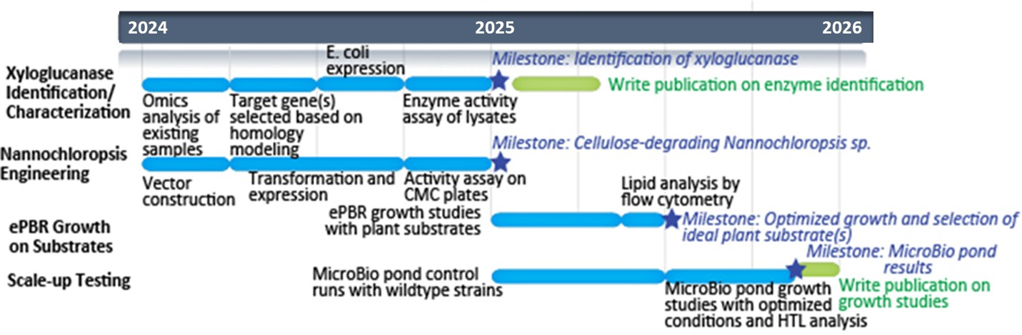

Figure 1. Example of a timetable graphic. A graphic such as this one gives an overview of major tasks, schedule, and milestones.

Mission Relevance and Program Development Plan (Suggested length: ½-1 page)

Provide a clear vision of how this work will contribute to future work at Sandia. How does the proposed work align with the purpose, objectives and goals of the Bioscience Research Foundation at Sandia and DOE/NNSA mission? How does the proposed work position Sandia at the forefront of the field? Consider citing the strategic plan or report with our relevant sponsors. Relevant documents could include:

* [Biological Systems Science Division Strategic Plan](https://science.osti.gov/-/media/ber/pdf/bssd/BSSD_Strategic_Plan_2021_HR.pdf)
* [Bioenergy Technologies Office Multi-Year Program Plan](https://www.energy.gov/sites/default/files/2023-03/beto-mypp-fy23.pdf)
* [DOE Foundational Science for Biopreparedness and Response Report](https://science.osti.gov/-/media/Initiatives/pdf/Bioprepardeness_Roundtable_Report_092722.pdf)
* [National Biodefense Strategy and Implementation Plan](https://www.whitehouse.gov/wp-content/uploads/2022/10/National-Biodefense-Strategy-and-Implementation-Plan-Final.pdf)

Qualifications of Principal Investigator (Suggested length: ¼ page)  
(does not count against page limit)

Briefly describe the qualifications of the Principal Investigator to conduct the research.

Budget   
(does not count against page limit)

Budget for 50% of PI time. Please describe equipment, or other purchases; and/or unusual travel. Keep in mind that Purchases and Travel cannot exceed 30% of the budget per year. Include in your estimate completion of a final report in the final year.

**Citations**(does not count against page limit)

Use the IEEE style to cite each reference: [*IEEE Style Guide*](https://ldrd.sandia.gov/ldrd_docs/ldrd_library_docs/5502/style_references_manual.pdf)

1. Lowry, O.H., Rosebrough, N.J., Farr, A.L., and Randall, R.J. (1951), Protein measurement with the Folin Phenol reagent, J. Biol. Chem., 193, doi: 10.1016/S0021-9258(19)52451-6.
2. Another publication
3. Another publication

Guidance on Hypothesis Generation:

Hypothesis—its definition, what it is and is not, and sentence stems to guide hypothesis generation. 